Abstract

Gyms can be jam-packed and can be hard for members to have a good workout in certain interval of time. As equipment are always taken by another member in the gym it would be really uncomfortable for you to wait beside him/her while he/she works out.  
I then decided to conduct various experiments in the gym to over come this solution.  
  
I then decided to create a feature where a member gets to see all the information with respect to the no of equipment available to use and also giving the member an option to book for equipment so he wouldn't need to wait next to a person while they're working out. With this feature, the members of the Gym can stay at home and look at the no of equipment being used and thereby make a decision to whether go to the gym or not.

The feature is added to an existing app.(PureGym App)  
  
In this report you'll be able to see two mid-fi prototype of the feature, methodologies used to conduct User testing along with two user test results of the prototypes.  
You'll also be able to see the feedback given by each User with respect to the features functionality and design.

**Introduction**   
“Gyms can be elbow to elbow with people in early January, making it tough to even complete a workout.” (Bryant, 2018).

<https://www.bodybuilding.com/content/3-ways-to-rule-a-crowded-gym.html>  
As a regular gym goer, I was often influenced by the strength of the Gym.   
The strength of the Gym determined the amount of time I spent in the gym.   
I was intrigued to know whether the Gym community was affected by this issue.   
  
At first, I decided to run a small experiment to figure out problems that concerned people in an overcrowded gym by visiting my University Gym from 6:00 to 7:30 pm in the evening as it is the peak time for students that use the University gym (cite), The busiest times of the day, and therefore the worst times to hit the gym, are mid-mornings (between 8 and 11 a.m.) and early evenings (4 to 7 p.m.).(Anderson, 2009)

<https://www.sparkpeople.com/resource/fitness_articles.asp?id=1259>

I noted down all the issues I encountered and tried to work them out individually.  
The main issue I encountered during this experiment was not knowing when particular equipment would be free to use and talking to strangers to find out if they were using equipment or not.   
  
I then decided to look at various ways I could overcome this concern and few of them were an   
image   
After doing this I came to the conclusion that one of the best ways to tackle this issue is by creating a simple token section for the users which could eliminate the need to talking with strangers and also which lets you know when your turn is.  
  
After a formative study, I found that more than half my users were influenced by the strength of their gyms, therefore I elected to create a token system (user interface) for current gym applications (Pure Gym) that could overcome these issues with respect to crowded gym based on the feedback I received in my studies.  
This included formative study to gather user requirements, along with two rounds of usability testing and evaluate the design with respect to the current gym application and user opinion on the functionality of the feature.

Background and Motivation

As a Gym Goer, It came to my notice that stuffed gyms influenced the amount of time I spent in the gym.  
It often led me to spend less time in the gym and therefore influencing my workout. The main reason I was being pulled back by crowded gyms were not having enough equipment to use and waiting for equipment to be free.   
I would often spend an hour or less if all the equipment is available to use, else I would be spending up to 2 hours which impacted the rest of my activities for the day, as Diogenes Laërtius stated: “Time is the most valuable thing that a man can spend.”   
There were days when I used to walk into the gym and walk right back by looking at the crowd, I then realised it would be much easier if I were to know how many people are in the gym and how many equipment’s are available to use before I could enter the Gym.   
It came to my notice from one of my friend's that their gym had an app that would let their members know, the number of people that are currently in the gym (Pure Gym). I later decided to research more on this feature by enquiring people who went to that gym (Pure Gym) to know if that feature influenced them by any sort. Most of them responded by saying that they would look at this feature to know whether the gym is crowded or not as this would make their decision whether to go to the gym or not.   
It also came to my notice that it would just let their users know the number of people in the gym but not the number of equipment being used.  
I then realised that If people were to know the number of equipment that is being used at that moment it would let them make a better decision to whether go to the gym or not as it would specify the equipment which they would want to use is available or not.   
I also noted that it could be better if the user were to be notified with a message informing about the equipment (they require), whether the equipment is available to use or not.   
A feature like this could definitely help people who value the time they spend in the gym and make better decisions before going to the gym.  
I noticed that most of the gym apps tend to display their workout plans or classes taking place in the gym but not many apps help the users know how many people are in the gym or how many equipment’s are being used.  
This feature motivated me to create a user interface for an existing app (Pure GYM).

**Methodology**   
  
For this project, I decided to create two Midfi prototypes for my user interface using PowerPoint. It allows for more flexibility, creativity and exploration during the implementation phase.  
(Fidelity and Craig, 2019) [https://www.webfx.com/blog/web-design/design-mockup-fidelity/](https://www.webfx.com/blog/web-design/design-mockup-fidelity/" \t "_blank)  
  
A simple consent form was handed to my users before I could run each of my tests.  
Participant Information Sheets and Consent Forms are important aspects of the organisation and conduct of a study.(Bio.cam.ac.uk, n.d.)  
[https://www.bio.cam.ac.uk/psyres/informationsheets](https://www.bio.cam.ac.uk/psyres/informationsheets" \t "_blank)  
  
1st Prototype - For my 1st prototype I decided to create a simple task for my user's, as it could lead them to understand the functionality of the feature better. My users were later interviewed face to face with a set of questions based on their understanding of this feature, once they completed the task. (ex-Was it easy to place yourself in the queue). Face-to-face interviews help with more accurate screening. (DeFranzo, 2014)  
[https://www.snapsurveys.com/blog/advantages-disadvantages-facetoface-data-collection/](https://www.snapsurveys.com/blog/advantages-disadvantages-facetoface-data-collection/" \t "_blank)  
  
2nd Prototype - For my 2nd prototype I decided to test the same users with the same set of tasks to understand if the functionality of the feature is conveyed to them better than my 1st prototype. My users were later interviewed face to face with a set of questions based on their understanding of this feature, once they completed the task.   
Face-to-face interviews can no doubt capture an interviewee’s emotions and behaviours. (DeFranzo, 2014)   
I decided to stick with the same users as it would let me know if I have rectified the flaw of my first prototype.   
[https://www.snapsurveys.com/blog/advantages-disadvantages-facetoface-data-collection/](https://www.snapsurveys.com/blog/advantages-disadvantages-facetoface-data-collection/" \t "_blank)  
  
SPIN Questionnaire  
This questionnaire was handed out to all of my above users to find out their scale for social anxiety disorder (social phobia).   
I decided to use this questionnaire to find out how likely a person with a score of more than 20 in the above questionnaire is going to use my feature compared to a person with a score of less than 20 and also to figure out if my feature has a higher impact on people with higher score in my questionnaire.   
  
User Evaluation

I decided to collect both Qualitative Data and Quantitative data from the users.

Qualitative data to test users understanding on the feature and Quantitative data for the time taken to complete the test.

Tools used to design the Prototype.  
I decided to use Microsoft PowerPoint to create my user interface,   
when it came to deciding the design for my feature I decided to keep it as transparent as I could to the current pure gym app. (i.e. making it seem like the feature has always been there).  
To keep it transparent I decided to add the same body colour to my feature by using colour picker ( [https://imagecolorpicker.com/](https://imagecolorpicker.com/" \t "_blank)). Colour Picker helped me pick the colour used in pure gym.  
I made use of Paint to crop pictures and resize them.  
As I could not figure out the font style I decided to stick the default styles given by PowerPoint.   
  
Tools used for Testing  
1. For my questionnaires to pick the right users, I decided to take a few questions from MarkETest (link [http://www.marketest.co.uk/market-research-questionnaire/577/fitness](http://www.marketest.co.uk/market-research-questionnaire/577/fitness" \t "_blank) )   
2. I made use of screen-o-Matic to record time spent on the task and to screencast them.   
3. I used my phone to record the interview and also to take pictures while the user does his testing.   
4. I decided to use SPIN (social phobia inventory) questionnaire for better results.  
The link of the questionnaire ( [https://www.serene.me.uk/tests/spin.pdf?\_](https://www.serene.me.uk/tests/spin.pdf?_" \t "_blank) )  
[Note- I would like you to know that I tried contacting the person responsible for creating this questionnaire for his consent to use the questionnaire. For any queries about the survey please contact [cd-risc.com/](http://cd-risc.com/" \t "_blank) ]

5. Microsoft Excel to convert Qualitative to Quantitative by adding charts.

Introspective Formative User Study

As a regular Gym Goer, I decided to note down all the issues I encountered while I was at the Gym. Going to the gym is great, but it is not without its problems. (BlazePress, 2014)  
[https://blazepress.com/2014/05/20-problems-every-gym-goer-can-relate/](https://blazepress.com/2014/05/20-problems-every-gym-goer-can-relate/" \t "_blank)  
  
As I enter the gym I often felt intimidated by people who were fairly bigger than me. I was regularly insecure about working out next to them or talking to them as It made me feel like I wasn't working out the appropriate way although I was doing it right. Everyone's body is different, so the way you do things is not necessarily the way everyone does things. (Mcdonald, 2017)  
  
If a person fairly bigger than me decided to wait beside me while I'm working out I would tend to reduce the reps of my workout as I felt uncomfortable and would let him use the machine.  
If you need to wait for a machine, don't do it while hovering over people finishing up their last sets. (Mcdonald, 2017)  
[https://www.huffingtonpost.co.uk/2014/03/05/gym-pet-peeves\_n\_4848613.html](https://www.huffingtonpost.co.uk/2014/03/05/gym-pet-peeves_n_4848613.html" \t "_blank)  
  
There were also a few situations that I encountered in the gym where I felt insecure and decided to step away from a machine with discomfort.  
One of them being- When I decided to look for a particular machine to use in the gym(bench press), I happened to notice that 4 of out of 5 machines were in use and one available. As I went up to the machine a person(bigger than me)  
asked me to not use the machine as he wanted to use it, although he was working out using another machine. As the person was bigger than me I was intimidated to tell him that I would like to use the machine until he finished his work out with the other machine but I decided to step away and let him use it.   
  
To reduce this I decided to design a feature that helps me know the no of equipment’s available to use at the moment so that I wouldn't need to step away from a machine that I'm allowed to use and also a notification system that helps me know when my turn is to use the machine which would then reduce people waiting beside people working out.

My first prototype

I decided to create a Mid-fi prototype using Microsoft PowerPoint. Those that see the mock-up phase as transitional, and thus should not take too much time. (Fidelity and Cao, n.d.)

[https://www.webfx.com/blog/web-design/design-mockup-fidelity/](https://www.webfx.com/blog/web-design/design-mockup-fidelity/" \t "_blank)

The pictures bellow shows the slides I used for my prototype testing. The full presentation can be accessed via OneDrive

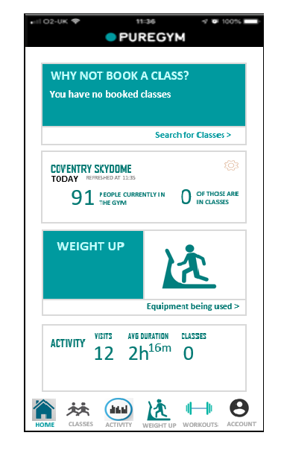The picture below is the home page for the Pure Gym app along with a new section called Weight Up.

Menu Icons that takes you to above sections

This section lets you know the amount of time you spent in the gym

This Section shows you the number of people currently in the Gym

This section lets you Book classes

This Section send you to Upper body, Lower body and Full body Equipment.

Highlighted icon to indicate user is on this page

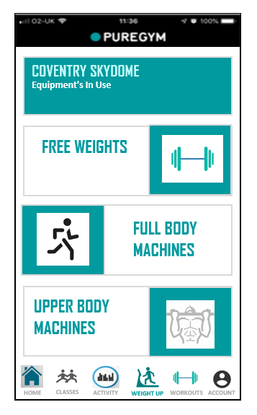

Displays all the Upper Body equipment in the gym

Displays all the Full Body equipment in the gym

Displays all the free weight equipment in the gym

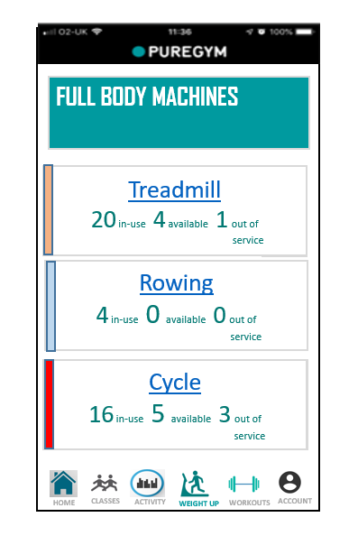

Clicking on treadmill or any other equipment name will send to you to another page where you could queue for it.

Shows all the equipment in Full body Machines along with the number of machines that are being used currently, Number of machines that are available to use along with no of machines that are out of service.

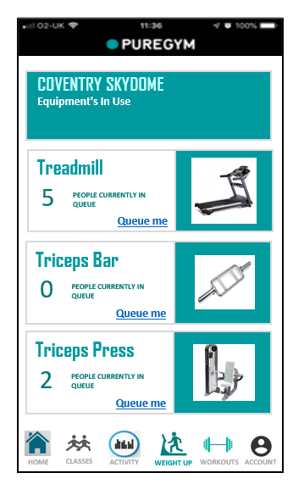

Let’s you know the number of people queuing for treadmill.

Picture display for people who do not how the equipment looks like

By clicking on this user will be placed in the queue.

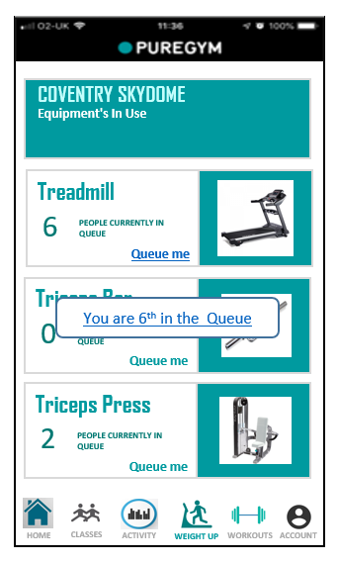

By clicking on “Queue me” earlier the screen refreshes and changes the number of people in the queue

By clicking on “Queue me” earlier the app send s you a notification stating what number you’re on the queue.

Once it’s the Users Turn to use the machine.

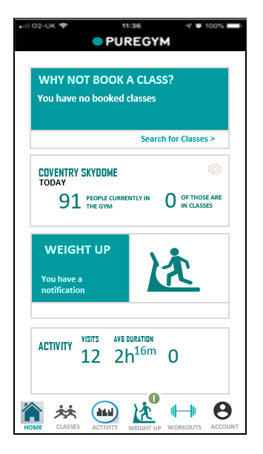

A notification badge

User then receives a notification and by either clicking “weight up” icon or “weight up section” user will be able to read the notification

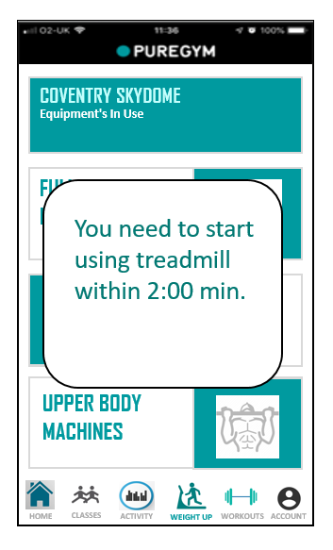

By clicking the notification badge a pop up screen is displayed which shows the amount of time left for the user to go and access the machine

Choosing the Right Candidate for my User Testing

For this activity, I decided to create three questionnaires to choose the right candidates for my user testing. "Recruiting the right participants is the most important part of conducting effective user research—especially when the number of participants is small."(Carol Barnum.2015)

<https://www.uxmatters.com/mt/archives/2015/09/recruiting-the-right-participants-for-user-research.php>

1st Questionnaire  
My first questionnaire was handed out to 8 users who do not use the gym.  
These questions were asked to examine the user's interest in gyms and their  
reason for not using the gym along with their views on gym applications.   
Users had to answer questions such as-  
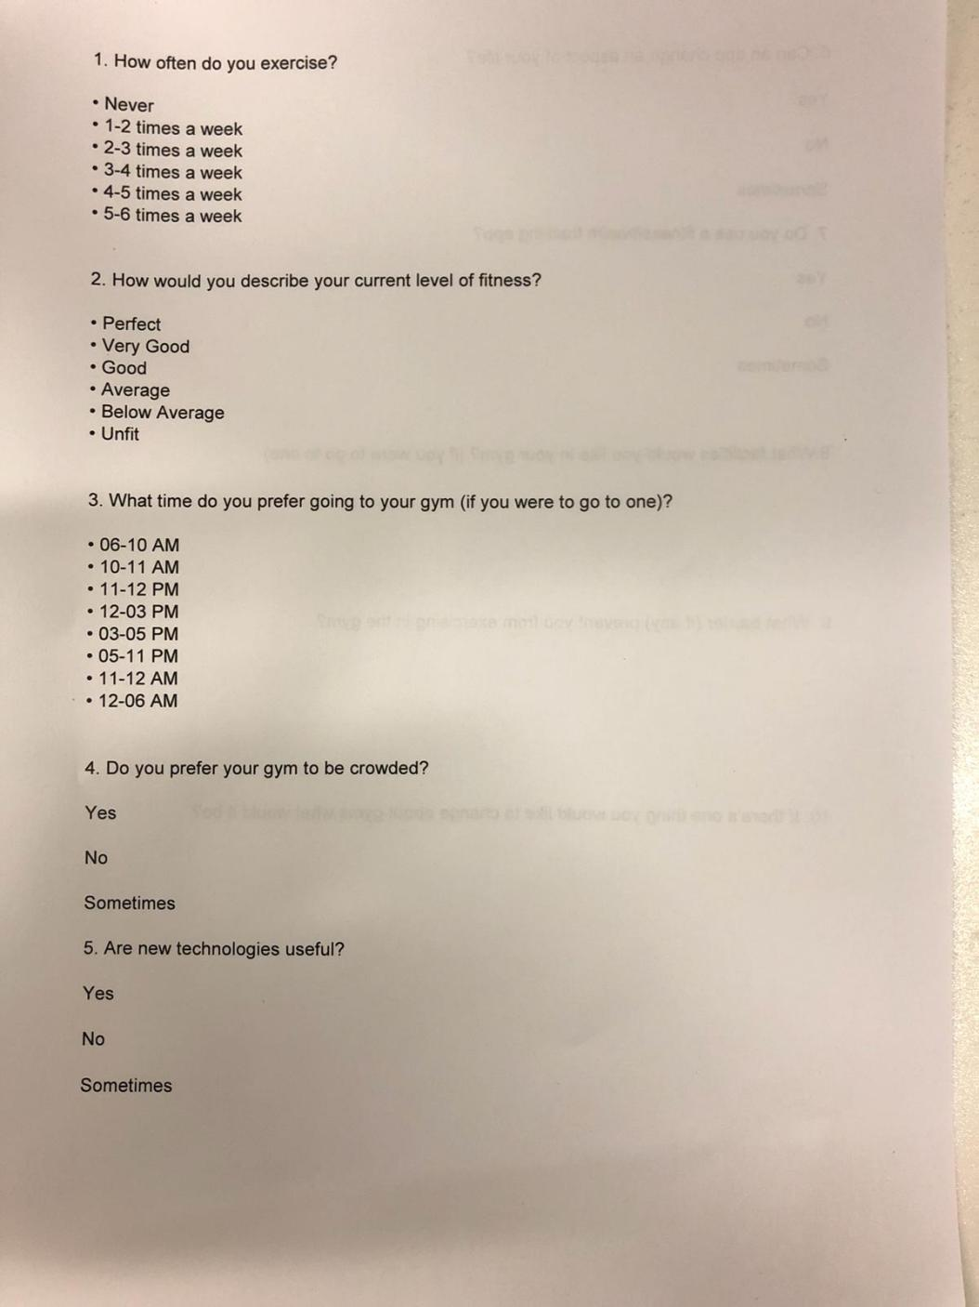  
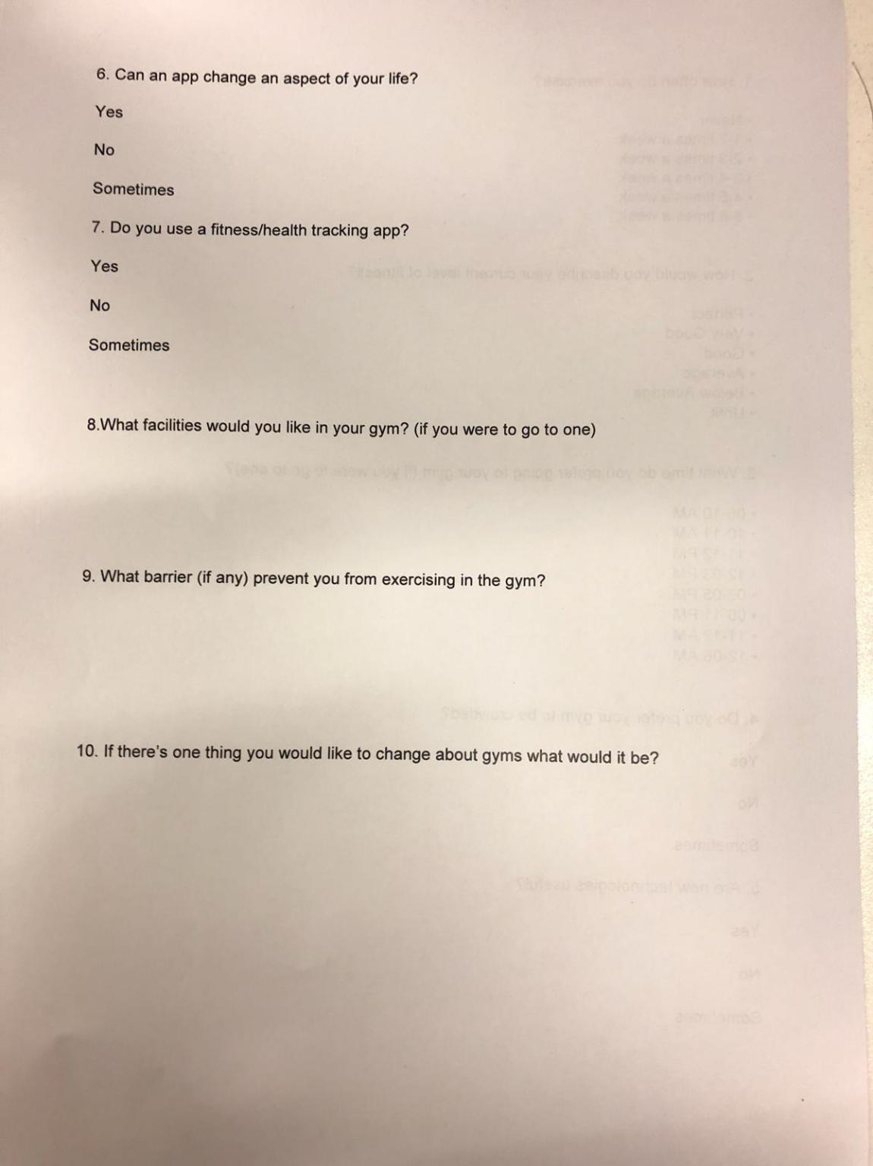  
  
  
To pick the right user for usability testing I decided to differentiate users based on their interest in the gym and technology; User 1 stated that he/she is disinterested to go to the gym and the user's interest in technology and apps are flat whereas my User 2 had a high interest in using gyms but due to lack of time the user is not able to use the gym. User 2 further has immense knowledge in technology as well as apps.   
  
For my user testing, I picked User 2 has the user is more likely to use my feature and user could let me know if a feature like this could encourage for he/she to join a gym.

2nd Questionnaire  
My second questionnaire was handed out to 4 users who use the gym but not Pure Gym (the app I am adding my feature into).  
The questions were asked to examine the user's interest in Gym, along with whether they used their gym app.   
Users had to answer questions such as-  
  
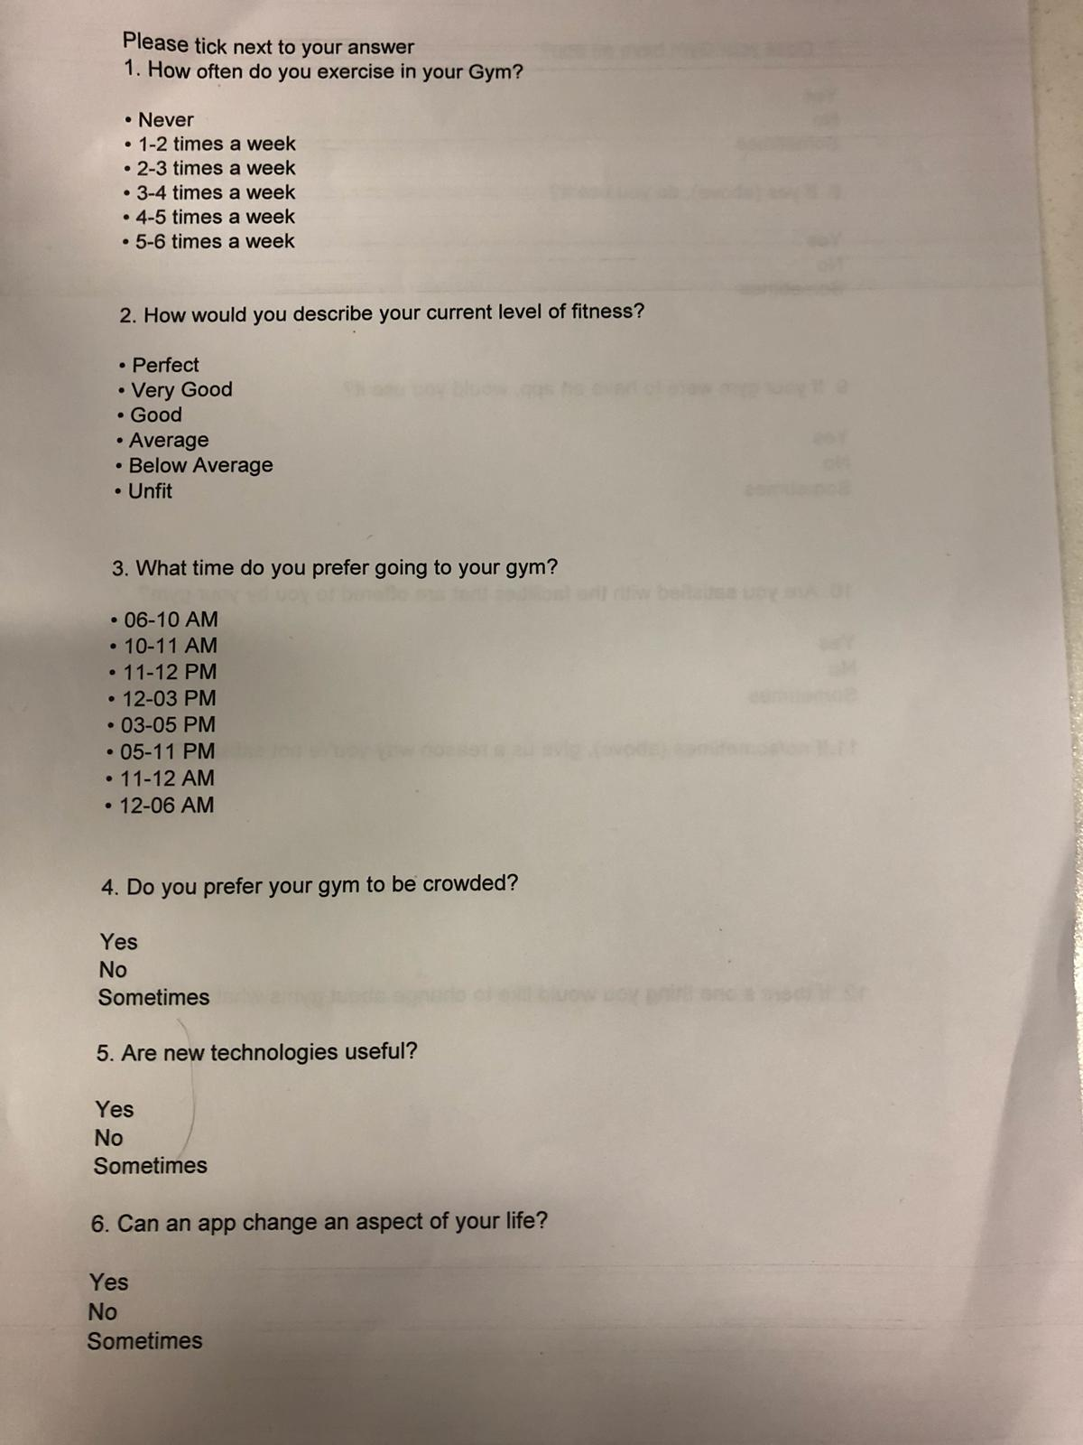

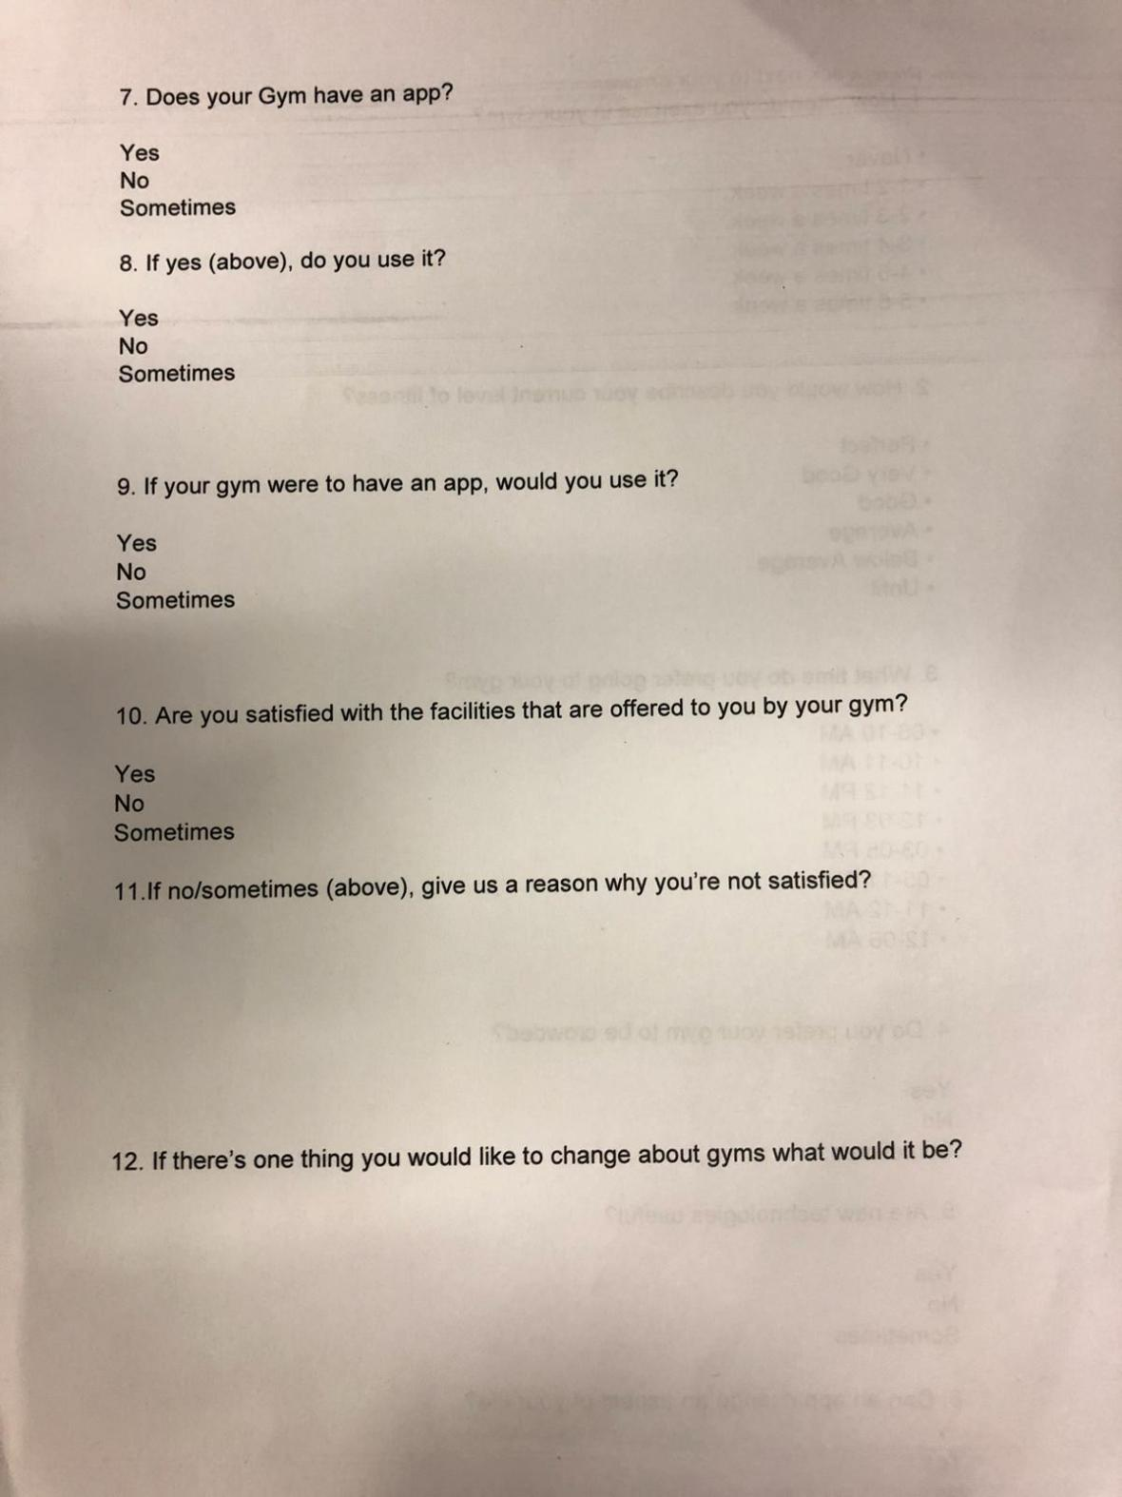  
  
To pick the right user for usability testing I decided to differentiate users based on their interest in Gym and technology; User 1 had a high interest in using the gym and also uses the gym app before to know more about gym classes and workout, whereas my User 2 stated that he/she is interested to go to the gym but barely had any interest in using gym app.   
  
For my user testing, I picked User 1 has the user is more likely to use my feature and user could let me know if a feature like this could encourage for he/she to book equipment and also address issues concerned to users current gym app.

3rd Questionnaire  
My third questionnaire was handed out to 5 users who use the pure gym (app used to add my user interface feature).  
The questions were asked to examine the user's interest in Gym, along with whether they used their gym app.   
Users had to answer questions such as-

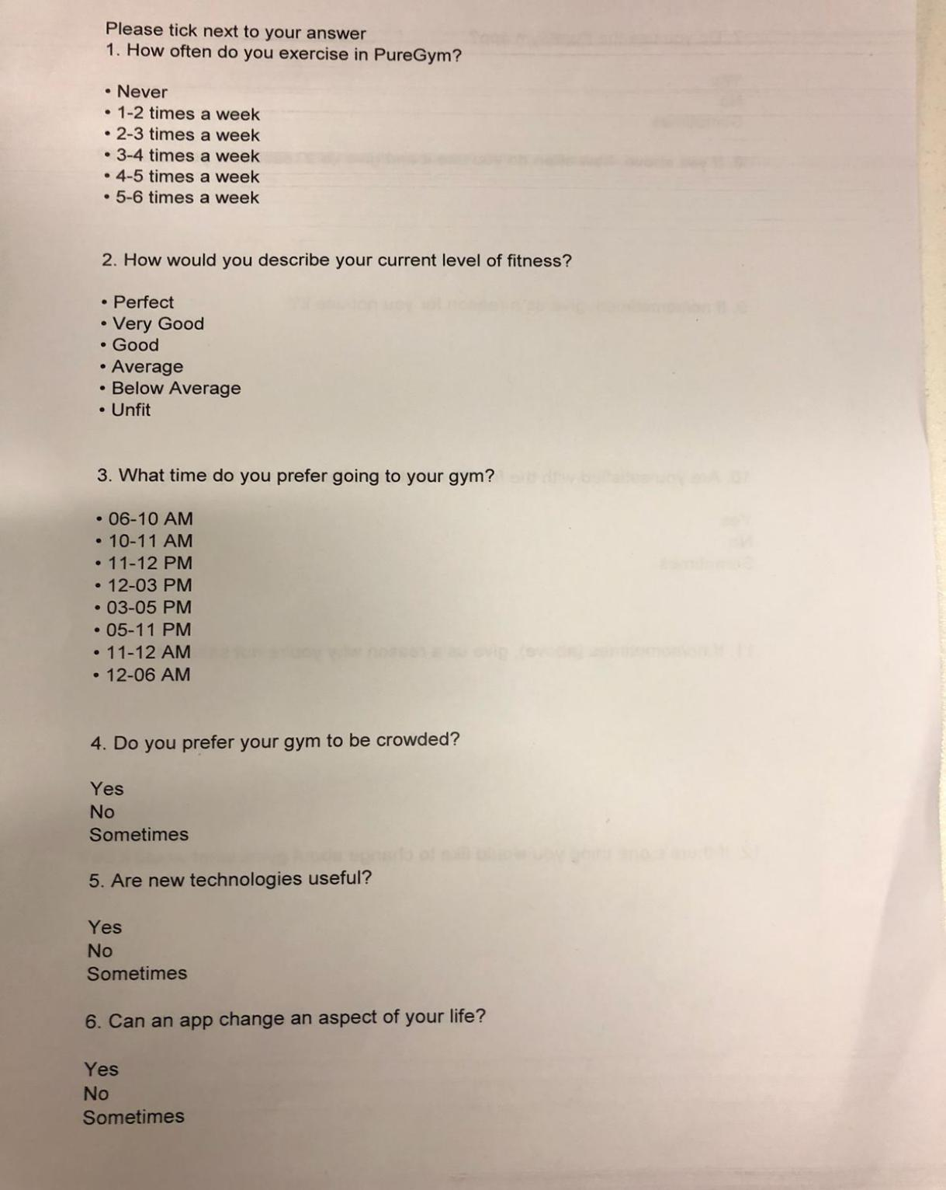

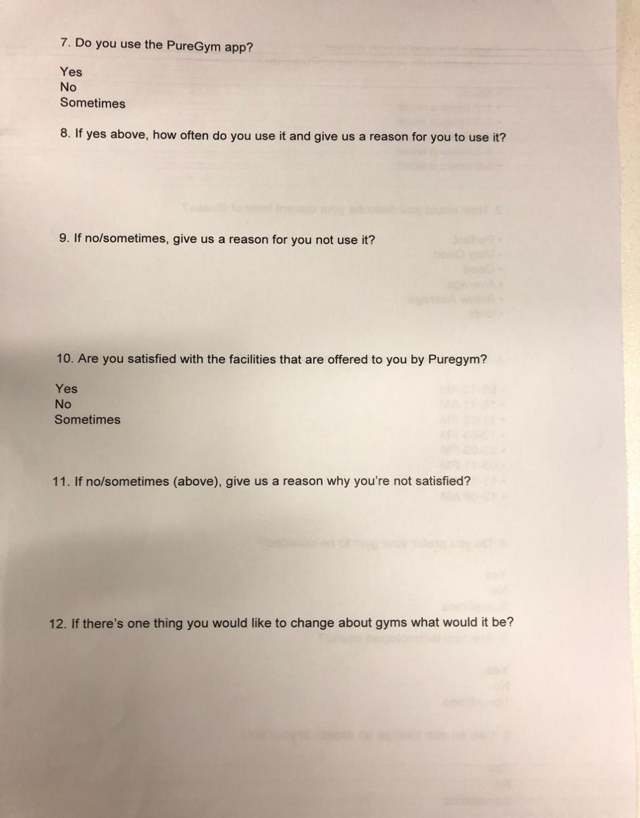  
  
To pick the right user for usability testing I decided to differentiate users based on their interest in Gym and technology; User 1 had a high interest in using the gym and also uses the gym app to know more about the number of people in the gym, whereas my User 2 stated that he/she is interested to go to the gym but barely had any interest in using gym app.   
  
For my user testing, I picked User 1 has the user is more likely to use my feature and user could let me know if a feature like this could encourage for he/she to book equipment, how this feature impacts his and also address issues concerned to users current gym app.  
  
These questionnaires helped me pick user that are keen in going to gyms and using technology. I’ve picked **6** users for my usability testing. **Three** of them do not use the gym, **two** of them use the pure gym and **one** of them goes to a different gym.

User Evaluation of Porotype 1

Once my users were done with their tasks, they were handed out a list of questions to answer with respect to the app.

I decided to interview my users because A face-to-face interview is no doubt going to capture verbal and non-verbal ques, but this method also affords the capture of non-verbal ques including body language, which can indicate a level of discomfort with the questions. (DeFranzo, 2014)

<https://www.snapsurveys.com/blog/advantages-disadvantages-facetoface-data-collection/>

The list of question asked to the users in the Interview were:

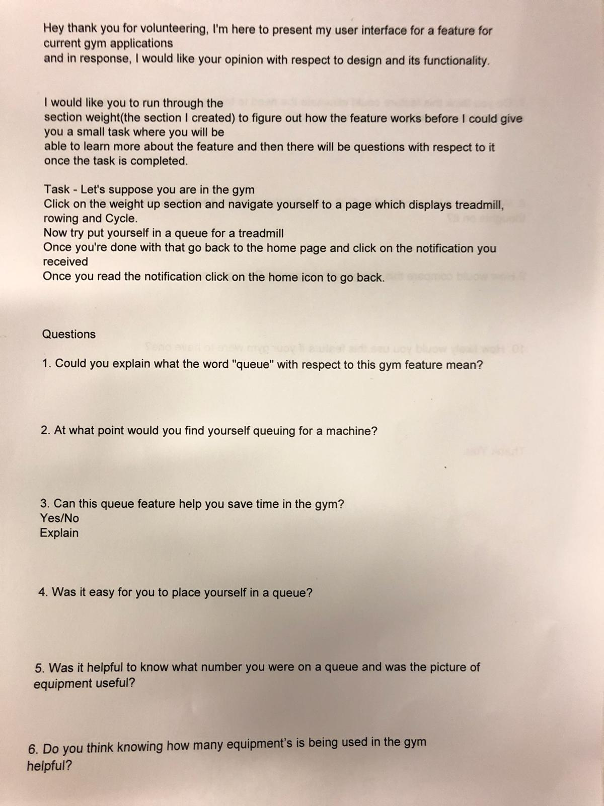

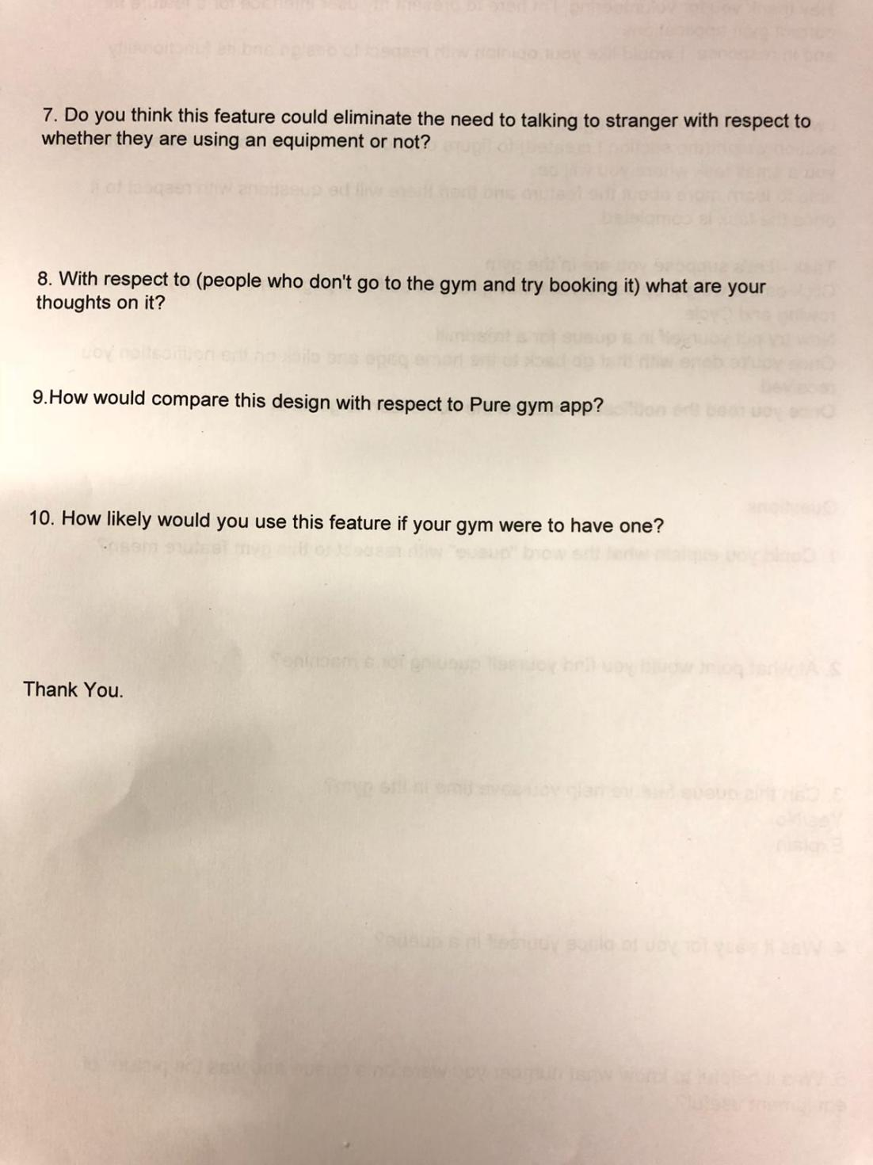

How can I improve the design of this interface?

Did not add this question in the image above but did ask users in my interview

Q No 1 2 3 4 5 6 7 8 9 10 11

|  |  |  |  |  |  |  |  |  |  |  |  |
| --- | --- | --- | --- | --- | --- | --- | --- | --- | --- | --- | --- |
| User1 | Notification when he queues for it | always | Yes 85% | Easy | Yes for number and picture | Did not understand the question | Mostly Yes | People should be allowed to book from home | Doesn’t know | Love to use it. | Notification bar |
| User2 | Wait in turn to use it | overcrowded | Yes | Easy | Yes for number and not really as user knew the picture | Yes | Yes | Didn’t answer | Slightly Similar | Every time in Gym | No improveme  nts |
| User3 | Order In which a person can queue | crowd | Yes | Easy | Yes for number and picture | Yes | Yes | People should not be able to queue when user not in gym | Similar | Definitely use it | Good, Notification |
| User4 | Waiting for gym machine to use it | When someone else is using something they need | Yes | Fairly Easy | Yes for number and picture | Yes, if everything is busy will not go to the gym | Yes | People should not be able to queue when user not in gym | Same | Will use as it prevents her from talking to strangers | Likes the design but icons can be  better |
| User5 | Puts in queue and notifies you when it’s your turn | Crowded | Yes | Easy | Yes for number and picture | Can help, how many are available is important | Eliminates they need to ask someone something  Yes | People should not be able to queue when user not in gym | Has more features than pure gym. | Yes would use it | Alignment  of texts |
| User6 | Notifies you when it’s your turn | Crowded | Yes | Very Easy | Yes for number and picture | Yes | Could eliminate,Maybe | People should not be able to queue when user not in gym | Similar | Likely to use it | Design is  good |

Please note- User have explained their reasoning to why they said yes or no. For explanation please listen to the interview

Tabular form of all the answers given by the user.

Charts

Converting above Qualitative data to Quantitative data

2Q – At what point would you find yourself queueing for the machine

When users would queue in for equipment in the gym

67% of my users agree to Queue when the gym is Crowded

33% of my users queue it for another reason

3Q – Can this queue feature help you save time in the Gym

When users would queue in for equipment in the gym

83% of my users agree to that queuing feature saves time

17% maybe

4Q – Was it easy for you to place yourself in the Queue

100% of my users say it was easy to place themselves in the queue

0% other

5Q – Helpful to know what number and picture was the useful?

100% of my users say it was helpful to see their queue number and picture

0% other

6Q –Knowing the equipment being used currently in the gym helpful?

67% of my users say it was helpful to see the equipment being used

16% Maybe

17% Other

0% No

7Q – Eliminates the need to talk to strangers

83% of my users say yes

17% Maybe

0% No

8Q – Comparing design with pure gym app

80% of my users say Similar

16% Better

17% Other

0% No

9Q – would they use the feature

67% Use it

33% Maybe Use it

0% No

Calculating the time taken for user to complete the task.



Calculating the quantitative data from user tasks table below:

|  |  |  |
| --- | --- | --- |
| Users | Time taken | Actions |
| Baseline | 6.8 sec | 7 actions |
| User 1 | 28 sec | 9 actions |
| User 2 | 1 min | 20 actions |
| User 3 | 18 sec | 7 actions |
| User 4 | 40 sec | 7 actions |
| User 5 | 35 sec | 8 actions |
| User 6 | 49 sec | 8 actions |

Above is a scatter graph showing the time taken and the number of actions for a user to complete the task. As you can see the actions taken stays consistent but the time taken in gradually increasing, it’s either the use was observing the features or was not able to understand the task during the task. As you can see one user took 20 actions to book a treadmill in 60 sec. This shows that actions can impact the time user takes to end the task.

**User Requirements**

With the feedback I received, I realised that most of my user were not happy with the notification bar therefore, for my second prototype I decided to add a new a notification bar.  
One of my users’ later suggested me to specify the treadmill number he needed to use within 2 min .I then realised that this would be a great feature as it would help to eliminate the need to talking to strangers. User would then won't have any issue looking for the equipment and there won't be a need to ask people to leave the machine.  
Most of my user took a long time to finish their task and therefore I decided to add a new features to my second prototype where I could make it quicker for the users’ to queue easily.

Second Prototype

For my second prototype I’ve decided to continue using PowerPoint. It can reduce the creation of unnecessary design components that might eventually be scrapped when developing the actual front-end. (Fidelity and Cao, 2019)

<https://www.webfx.com/blog/web-design/design-mockup-fidelity/>

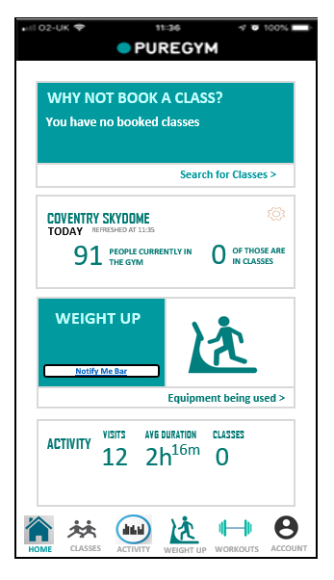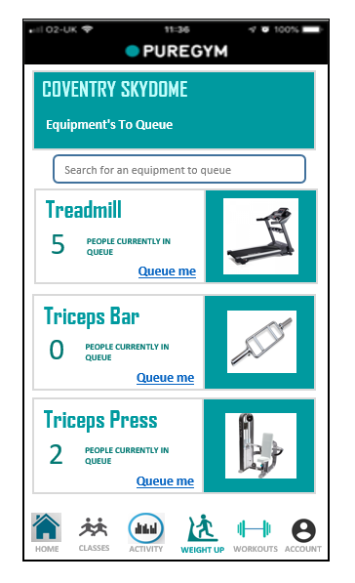

To queue for an equipment

Search bar that helps you look for equipment to queue

This Section send you to Upper body, Lower body and Full body Equipment.

By clicking on it, you’ll be navigated to the page where you can queue for machines.

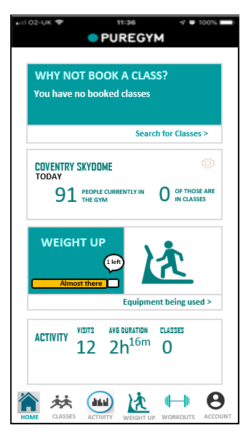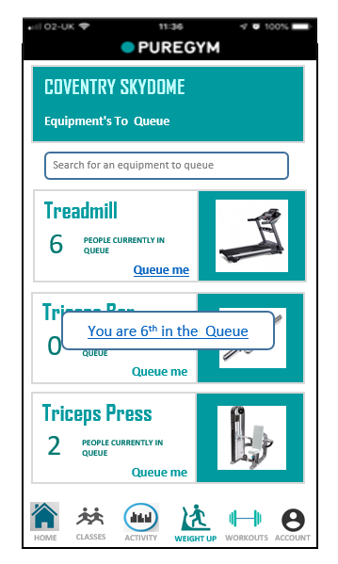

Notify me bar fills up as you get close to your turn. Also displays the no of people left in the queue

What Number you are on the queue

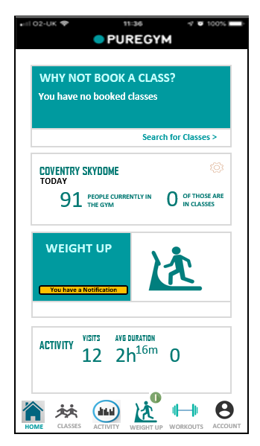

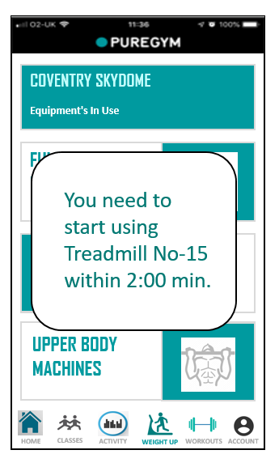

Notification

Specifies the Treadmill Number you need to use within 2:00 min

Let’s you know that you have a notification and by clicking on it you can view the notification

**User Evaluation Second Prototype**

For this I decided to create the same task with a minute addition for the users to help them queue for a treadmill faster.

Task and interview questions asked for this prototype are:-

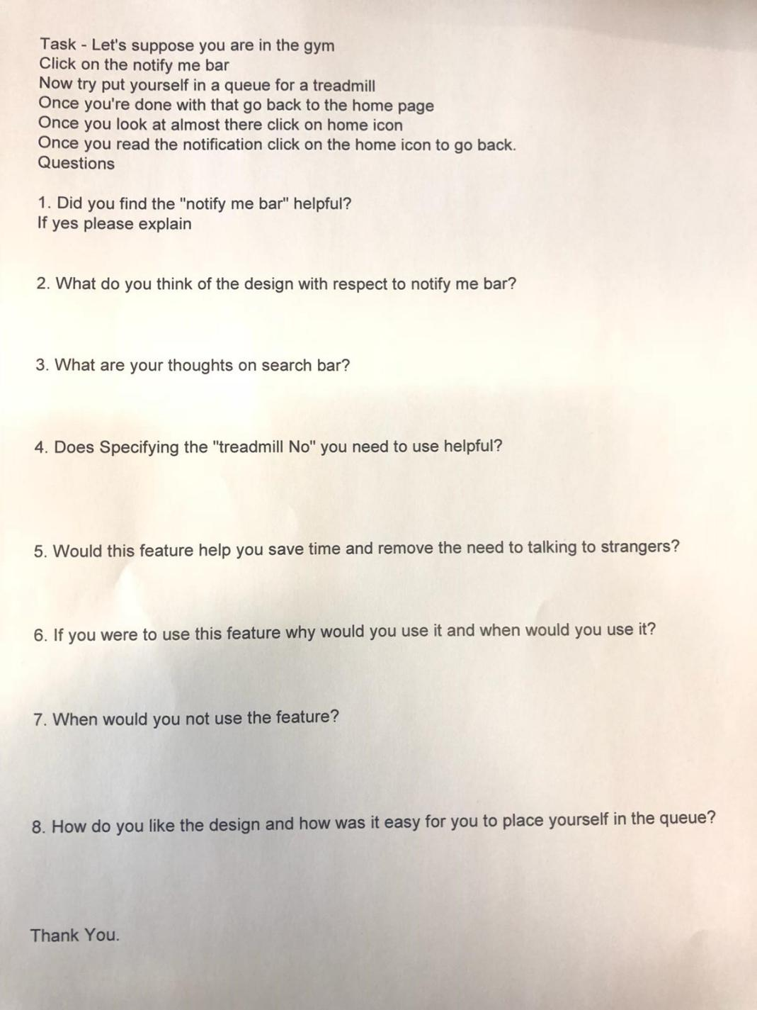

Calculating the quantitative data from user tasks table below:

|  |  |  |
| --- | --- | --- |
| Users | Time taken | Actions |
| Baseline | 7 sec | 6 actions |
| User 1 | 20 sec | 6 actions |
| User 2 | 20 sec | 6 actions |
| User 3 | 31 sec | 6 actions |
| User 4 | 32 sec | 6 actions |
| User 5 | 22 sec | 6 actions |
| User 6 | 28 sec | 6 actions |

Above is a scatter graph showing the time taken and the number of actions for a user to complete the task. As you can see the actions taken stays consistent but the time taken in gradually increasing, it’s either the use was observing the features or was not able to understand the task during the task.

Compared to my earlier prototype I decided to make it easier for the user to navigate to the queue me page by clicking on the notify me bar, therefore making to easier for them to book and reduce the no of actions.

Qualitative Data

Q No 1 2 3 4 5 6 7 8

|  |  |  |  |  |  |  |  |  |
| --- | --- | --- | --- | --- | --- | --- | --- | --- |
| User 1 | Yes, instruction very clear | Fits great | Important thing, helps to find equipment | Yess, where they need to go and what they have to do | Helps to save time and remove the need to talk to stranger | Has the user is really busy it would help him a lot | Lazy or else if the user interface were to be really hard to use | Its Great, Very easy to queue |
| User 2 | Yes, links directly to queue page | Its fine | Wide enough and used to search for equipment | Yes, will be very helpful | Yes | Don’t like talking to strangers, mainly use it for treadmill | Gym is free and empty to use | Everything Is ok |
| User 3 | YES | Like the design | Really like the idea but was not able to use in this task | Yeah very useful | Yeas and user doesn’t want any intimidating person talking to him | Would use it when he doesn’t want to talk to anyone | When user is at home | Simple and easy to use |
| User 4 | Yeah, would use the bar to see the progress of the queue | Small, make it bigger | If there are a lot of equipment in the gym then it is really god | Yes, need to know which treadmill to use | Yes | Use would use it as the user is anti-social, user would use it all the time for this reason | If user was a social person then she wouldn’t use it | Like the design and very easy |
| User 5 | Yes, found it helpful | Able to understand | Makes it easier to look around equipment | Extremely Helpful | Sure saving time does help but talking does not think it can eliminate the need for talking to stranger | Use it in the gym to cut back a little time and organize better before. | Can’t think of anything at this moment | Easy to queue and likes the design |
| User 6 | Yes, to get an estimate of how many people left | Likes it, very visible | Will help me queue for an equipment easily | Yes, help me from not going to random people machines | Yes it does allow us to save time and eliminate the need to talking to stranger | Use it when the gym is crowded | When gym is really crowded | Same as pure gym and easy to use |

Qualitative to Quantitative

Q1- Notify me Bar ‘Helpful’?

100% - all my users agreed that the bar is helpful

Q2- Design aspect of Notify me Bar?

Different views of my user.

Most of them liked the notify me bar

Q3- Specifying the Treadmill Number?

All my users agree with it.

Q4- Thoughts on Search Bar?

100 % of my user like to use a search bar

By the end of my User test I ask my users’ to fill up a questionnaire (social phobia Inventory).

I believed that a person with a score of more than 20 on this questionnaire would definitely be a person who is interested in using this app.

|  |  |
| --- | --- |
| User | Social Phobia Inventory (Score) |
| User 1 | 22 |
| User 2 | 24 |
| User 3 | 5 |
| User 4 | 29 |
| User 5 | 8 |
| User 6 | 28 |

By comparing their qualitative data and their Social Phobia inventory I came to an assumption that User 1, User 2, User 3 and User 6 would use this app has they’re insecure of crowd and have mentioned it earlier.

User Requirements

After my second prototype most of user were happy with my end result and one of them asked me to just change the notification bar button.

Discussion and Future Work

There’s a technique for **improving one’s user interface design skills** that is the most efficient way I know of expanding one’s visual vocabulary but that I’ve rarely heard mentioned by digital designers. (Kennedy, 2017) <https://www.smashingmagazine.com/2017/02/improving-ui-design-skills-copywork/>

Before I could design my user Interface, I decided to investigate the pure gym app to find all its feature and its designs. I then decide to add a new feature called Weight up as it would help user know about the amount equipment available to use and being able to place yourself in a virtual queue to use one. I then decided to create questionnaires to pick out the right candidate for my usability testing. I was able to pick 6 users from these surveys and was able to test my prototype on them. My users were allowed to understand what my feature was and later a simple test was given to them where they used my equipment to book it. I was able to get my users to understand my feature which was my main goal for this assignment. My users then gave me their feedback in the for of an interview.

Most of my feedback stated that, this feature would be a great product for the current gym users. Which would also help people who are socially insecure in Gym.

Reflecting on what I’ve, I realised that I could’ve had more users to test my app and interview people who work in gym for a better feedback. With respect to my design I wish I could’ve found the pure gym font style and size to make it as transparent as I could with respect to pure gym. I wish I could re do my interview question cause few of them were not sentenced right or poorly constructed. I wish I could’ve started to write report earlier as I could have done more research on qualitative and quantitative data.

Overall the project was a great learning experience for me as I am really interested in innovating something new.

**References**

Bio.cam.ac.uk,(n.d.) from:  
[https://www.bio.cam.ac.uk/psyres/informationsheets](https://www.bio.cam.ac.uk/psyres/informationsheets" \t "_blank)

BlazePress (2014)from:  
[https://blazepress.com/2014/05/20-problems-every-gym-goer-can-relate/](https://blazepress.com/2014/05/20-problems-every-gym-goer-can-relate/" \t "_blank)

# Bryant(04/01/ 2018) 3 Ways To Rule A Crowded Gym available from:

<https://www.bodybuilding.com/content/3-ways-to-rule-a-crowded-gym.html>

Carol Barnum(2015)from:

<https://www.uxmatters.com/mt/archives/2015/09/recruiting-the-right-participants-for-user-research.php>

DeFranzo (2014)from:  
[https://www.snapsurveys.com/blog/advantages-disadvantages-facetoface-data-collection/](https://www.snapsurveys.com/blog/advantages-disadvantages-facetoface-data-collection/" \t "_blank)

Fidelity and Craig(2019) A Guide to Prototype Fidelity from:

[https://www.webfx.com/blog/web-design/design-mockup-fidelity/](https://www.webfx.com/blog/web-design/design-mockup-fidelity/" \t "_blank)

Fidelity and Craig(2019) A Guide to Prototype Fidelity from:

[https://www.webfx.com/blog/web-design/design-mockup-fidelity/](https://www.webfx.com/blog/web-design/design-mockup-fidelity/" \t "_blank)

Fidelity and Cao(n.d.) from:

[https://www.webfx.com/blog/web-design/design-mockup-fidelity/](https://www.webfx.com/blog/web-design/design-mockup-fidelity/" \t "_blank)

Fidelity and Cao( 2019)from:

<https://www.webfx.com/blog/web-design/design-mockup-fidelity/>

Jason Anderson (1/20/2009) beat the crowd at the gym available from:

<https://www.sparkpeople.com/resource/fitness_articles.asp?id=1259>

Mcdonald (2017)from:  
[https://www.huffingtonpost.co.uk/2014/03/05/gym-pet-peeves\_n\_4848613.html](https://www.huffingtonpost.co.uk/2014/03/05/gym-pet-peeves_n_4848613.html" \t "_blank)

Appendix

Consent Forms along SPIN Survey-

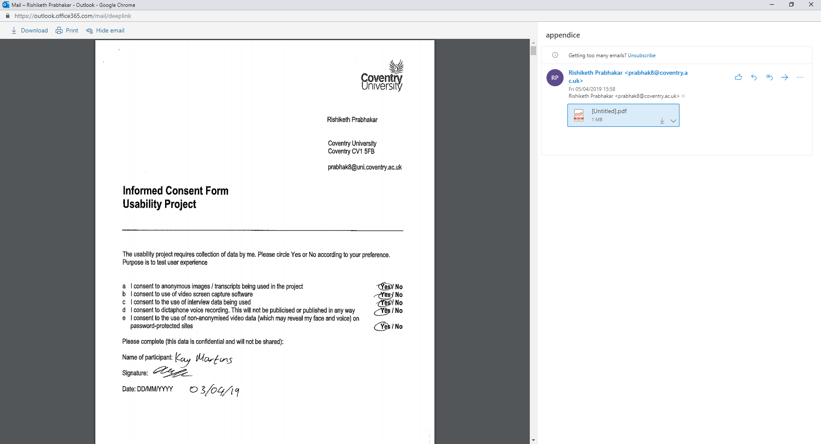

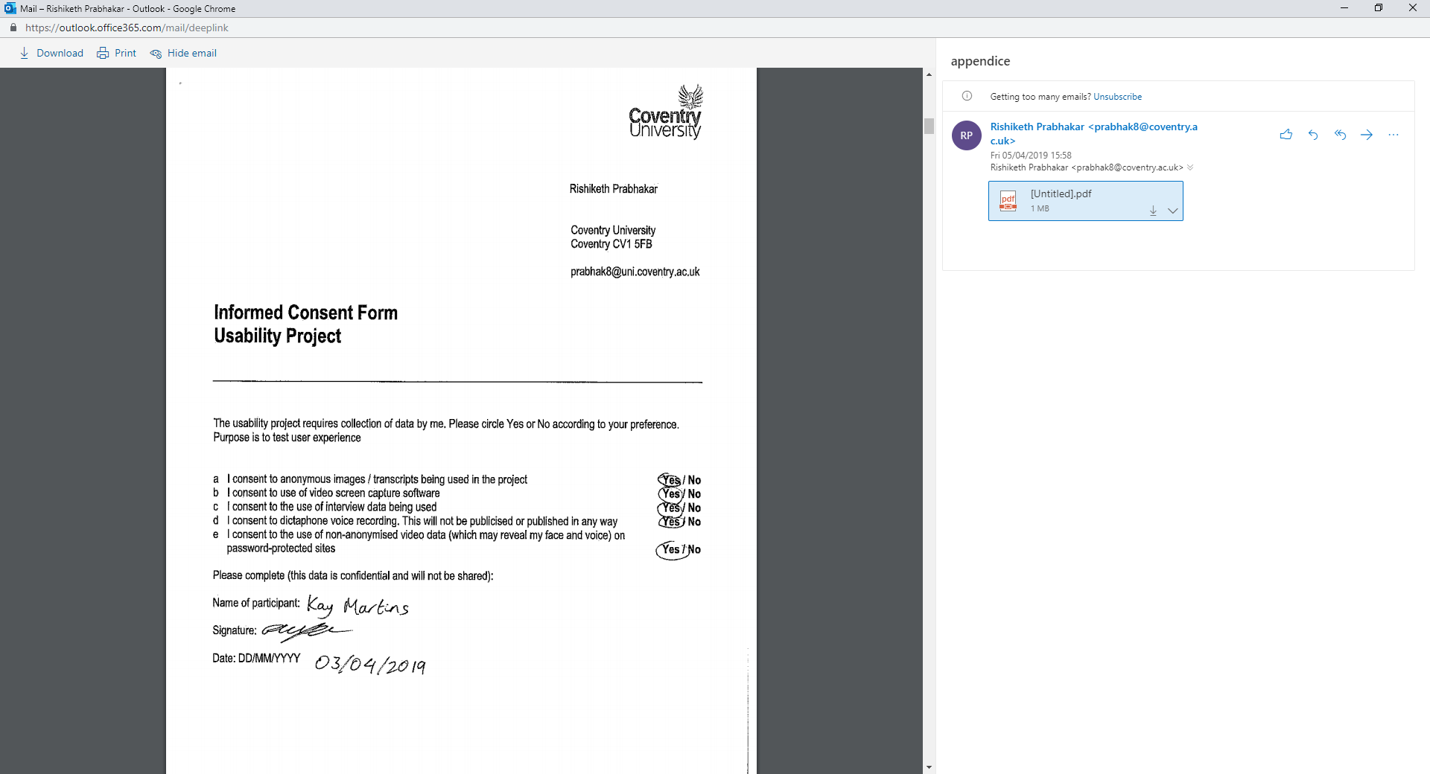

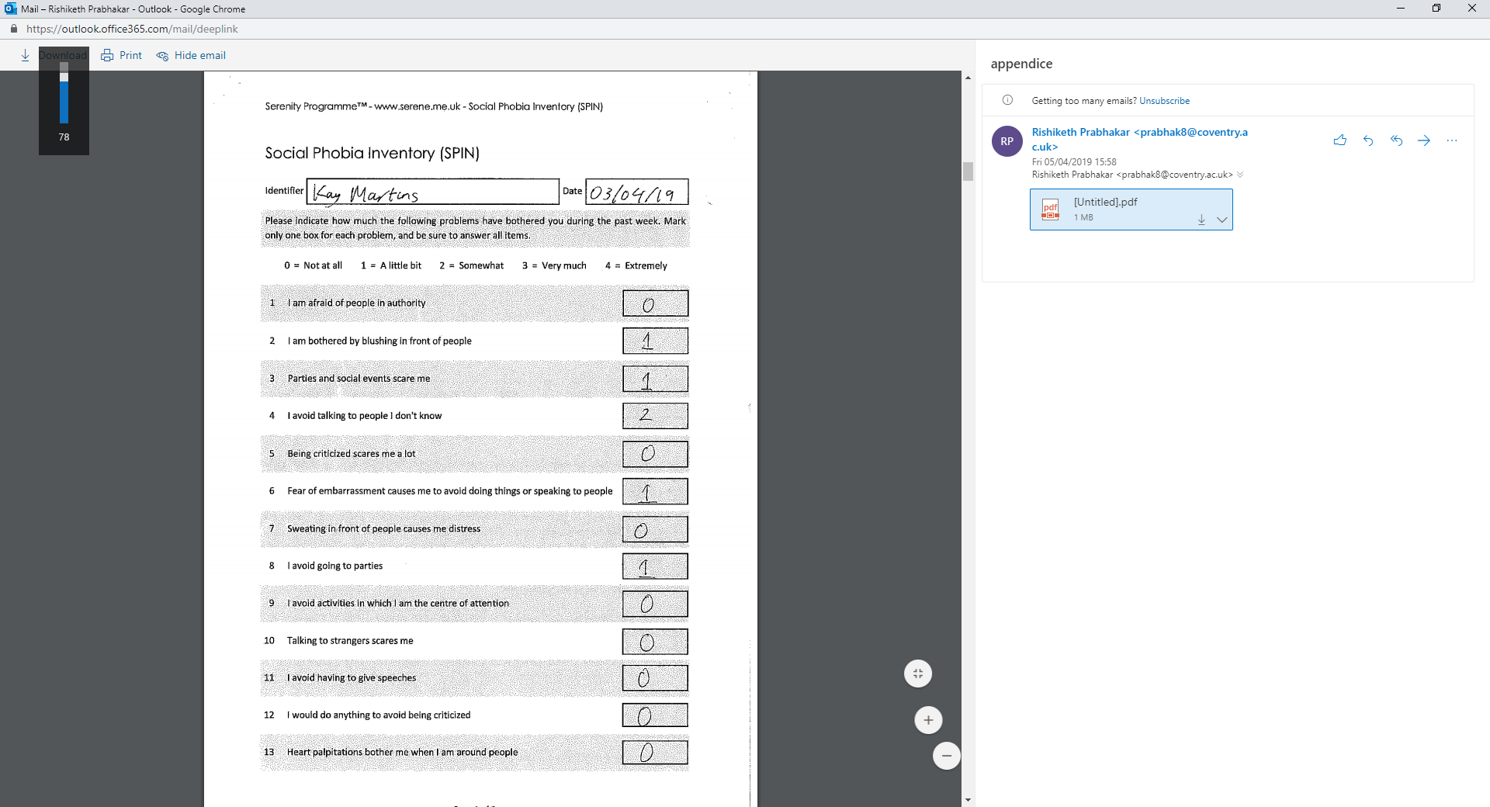

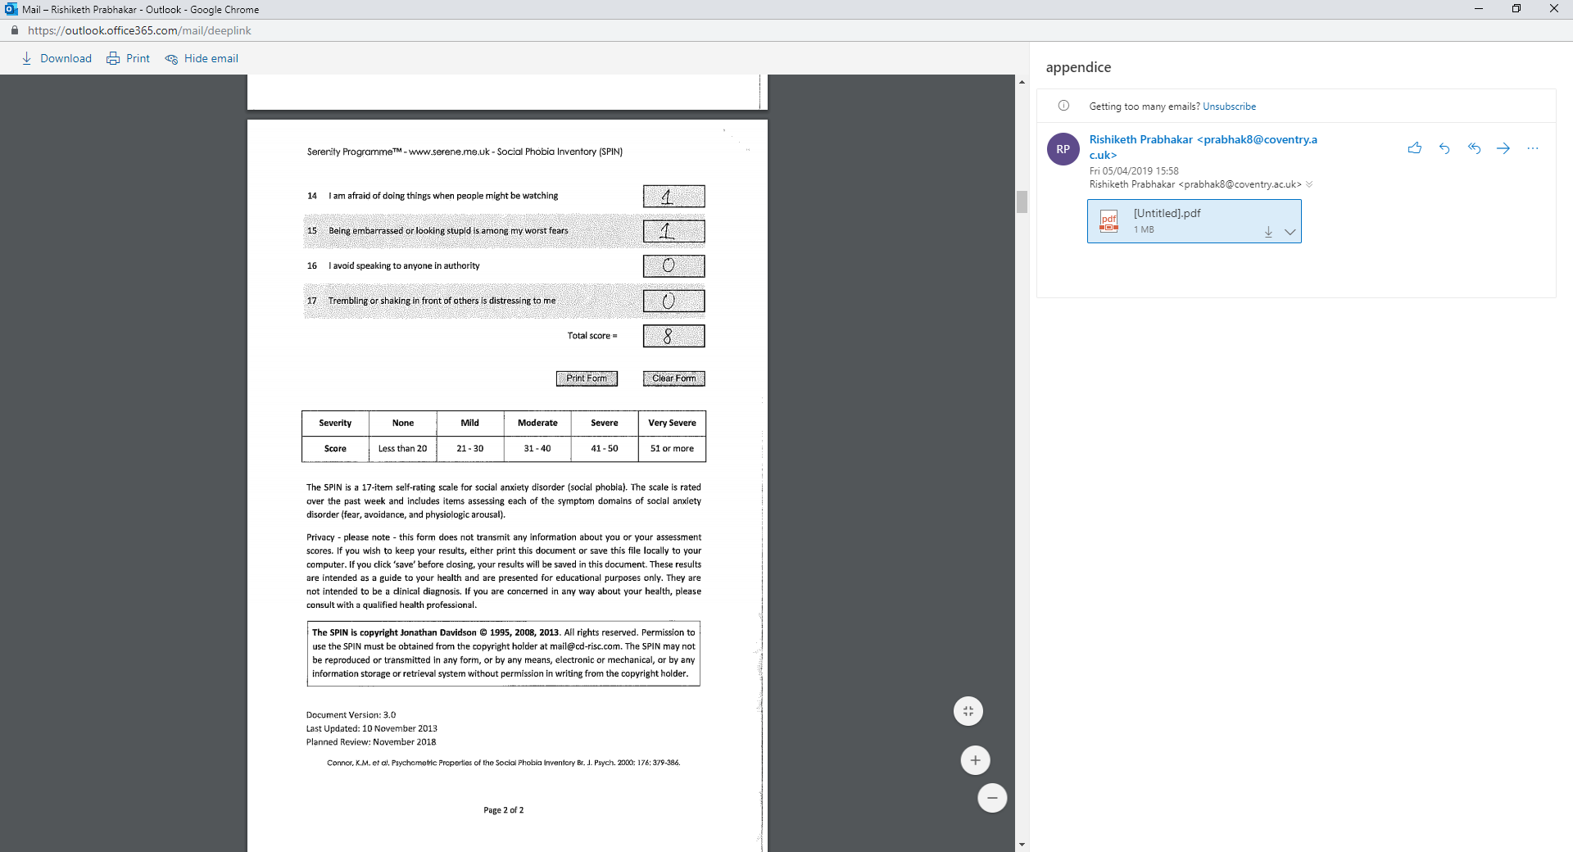

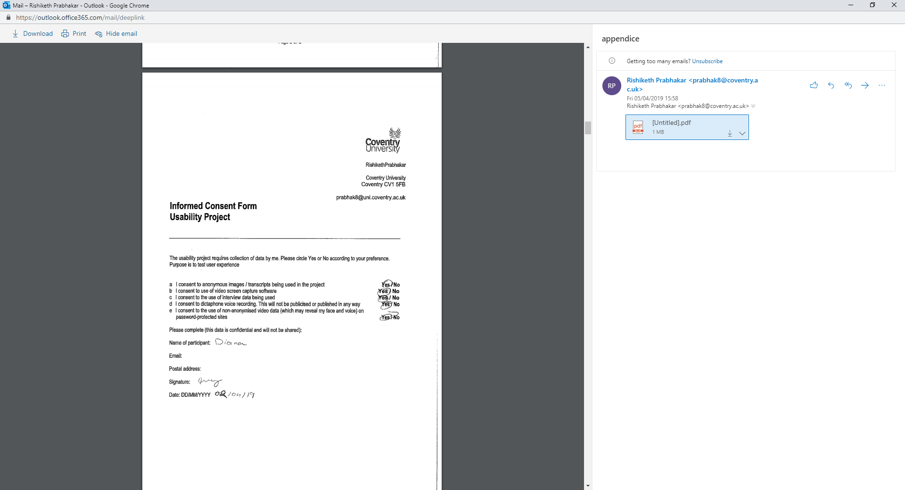

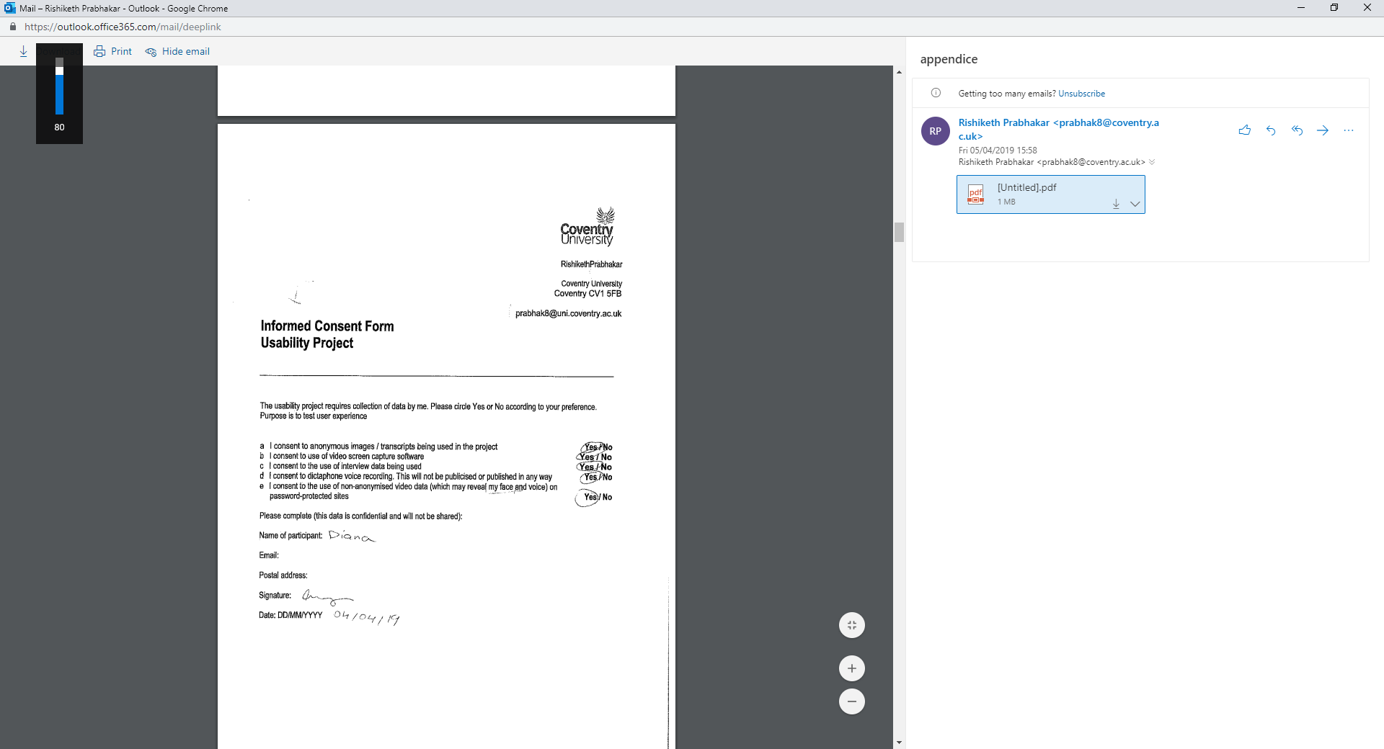

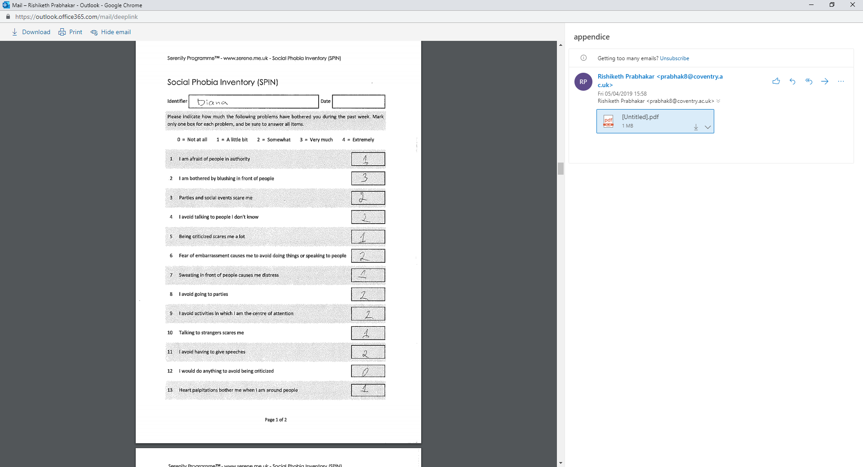

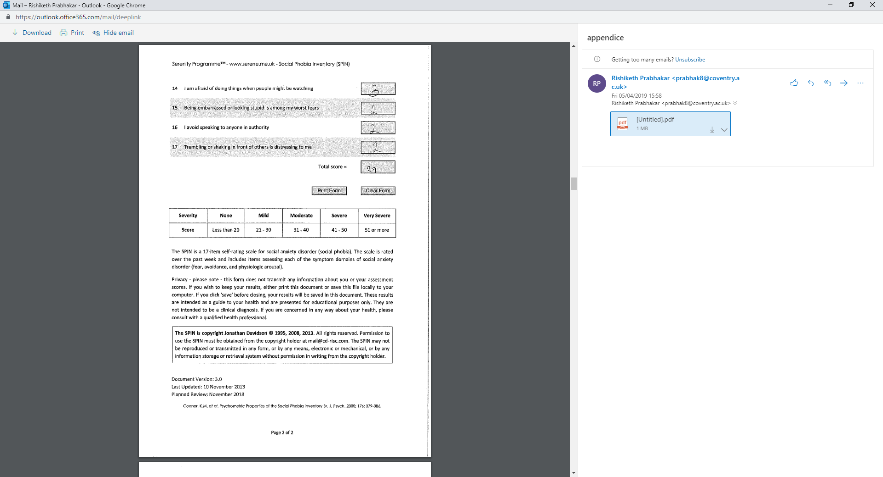

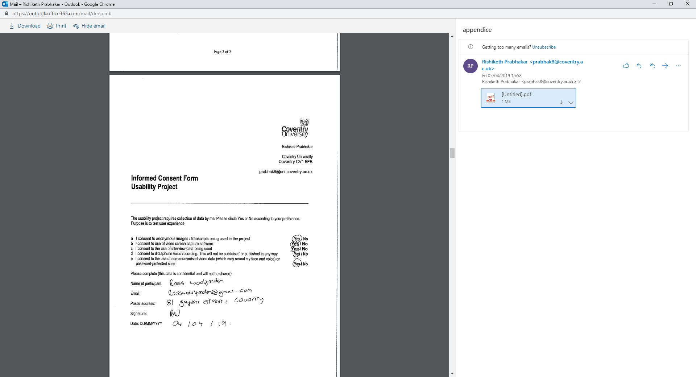

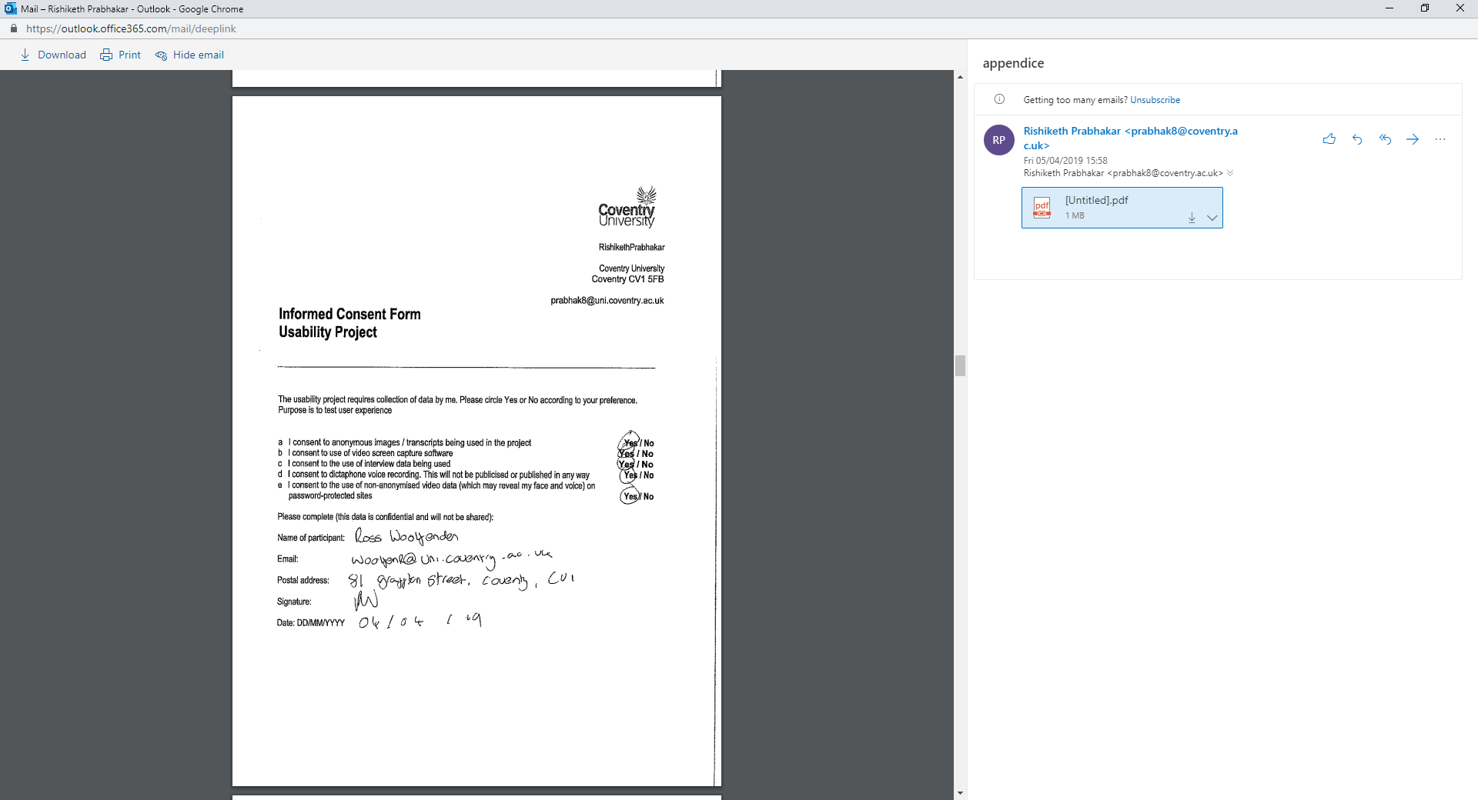

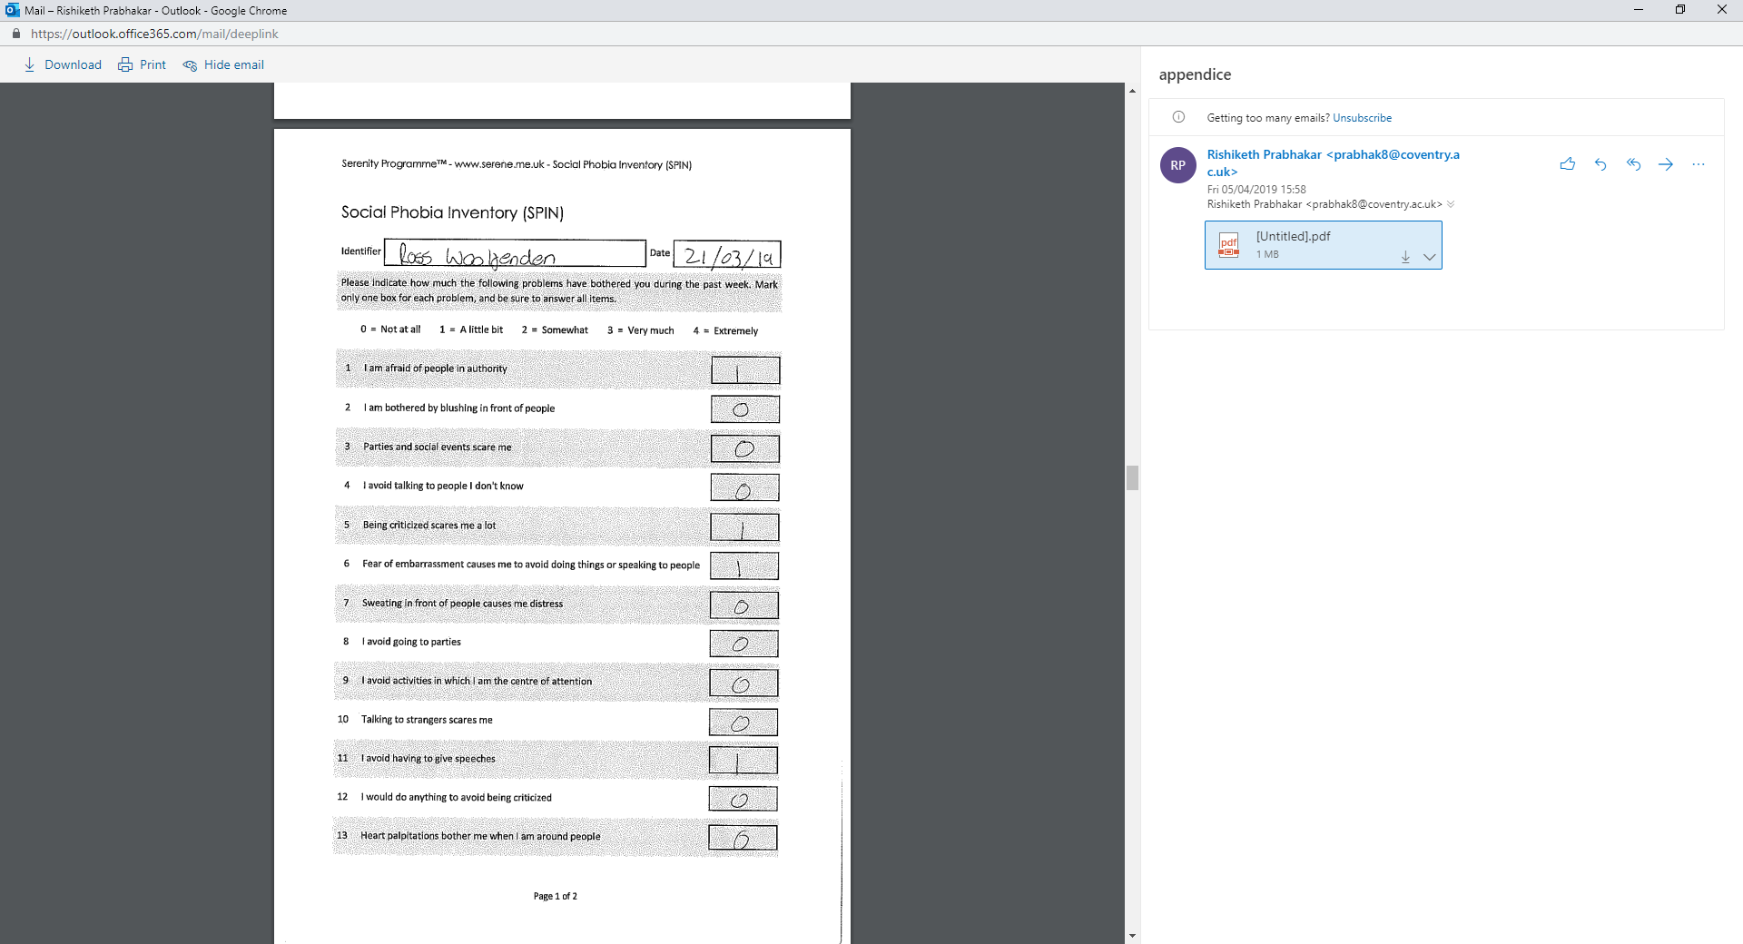

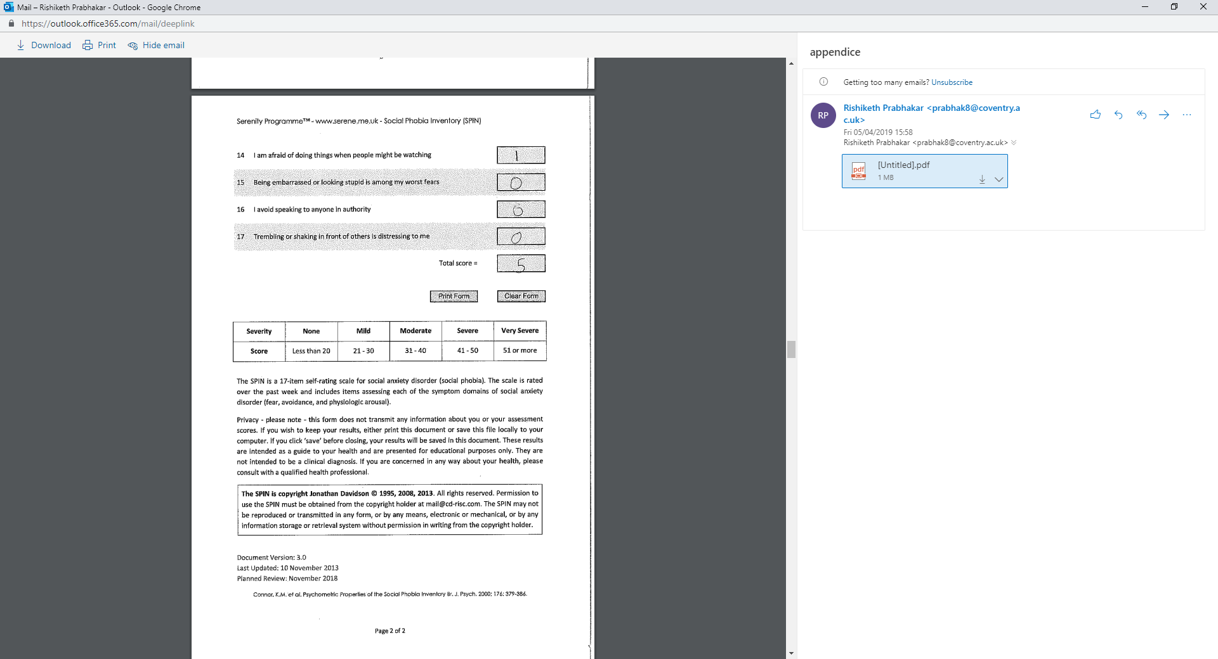

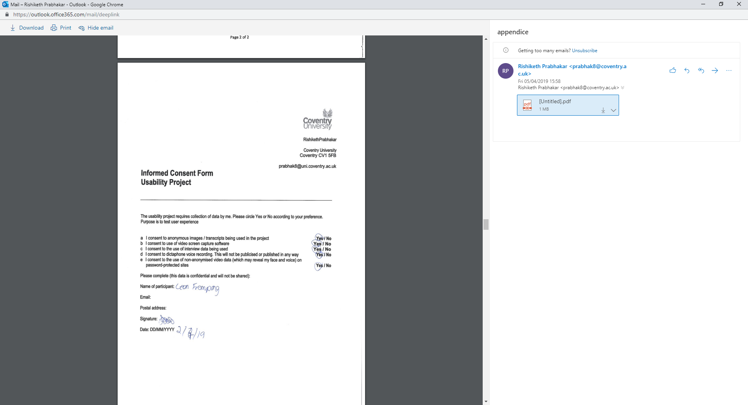

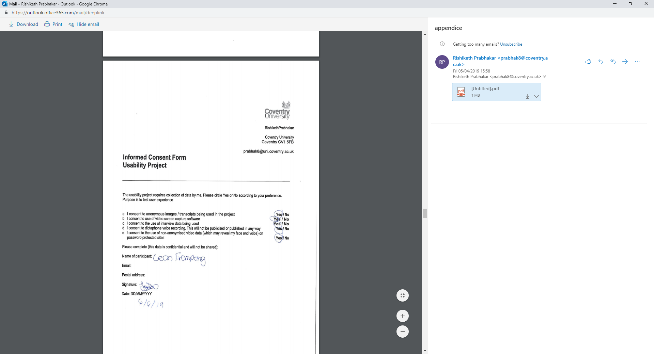

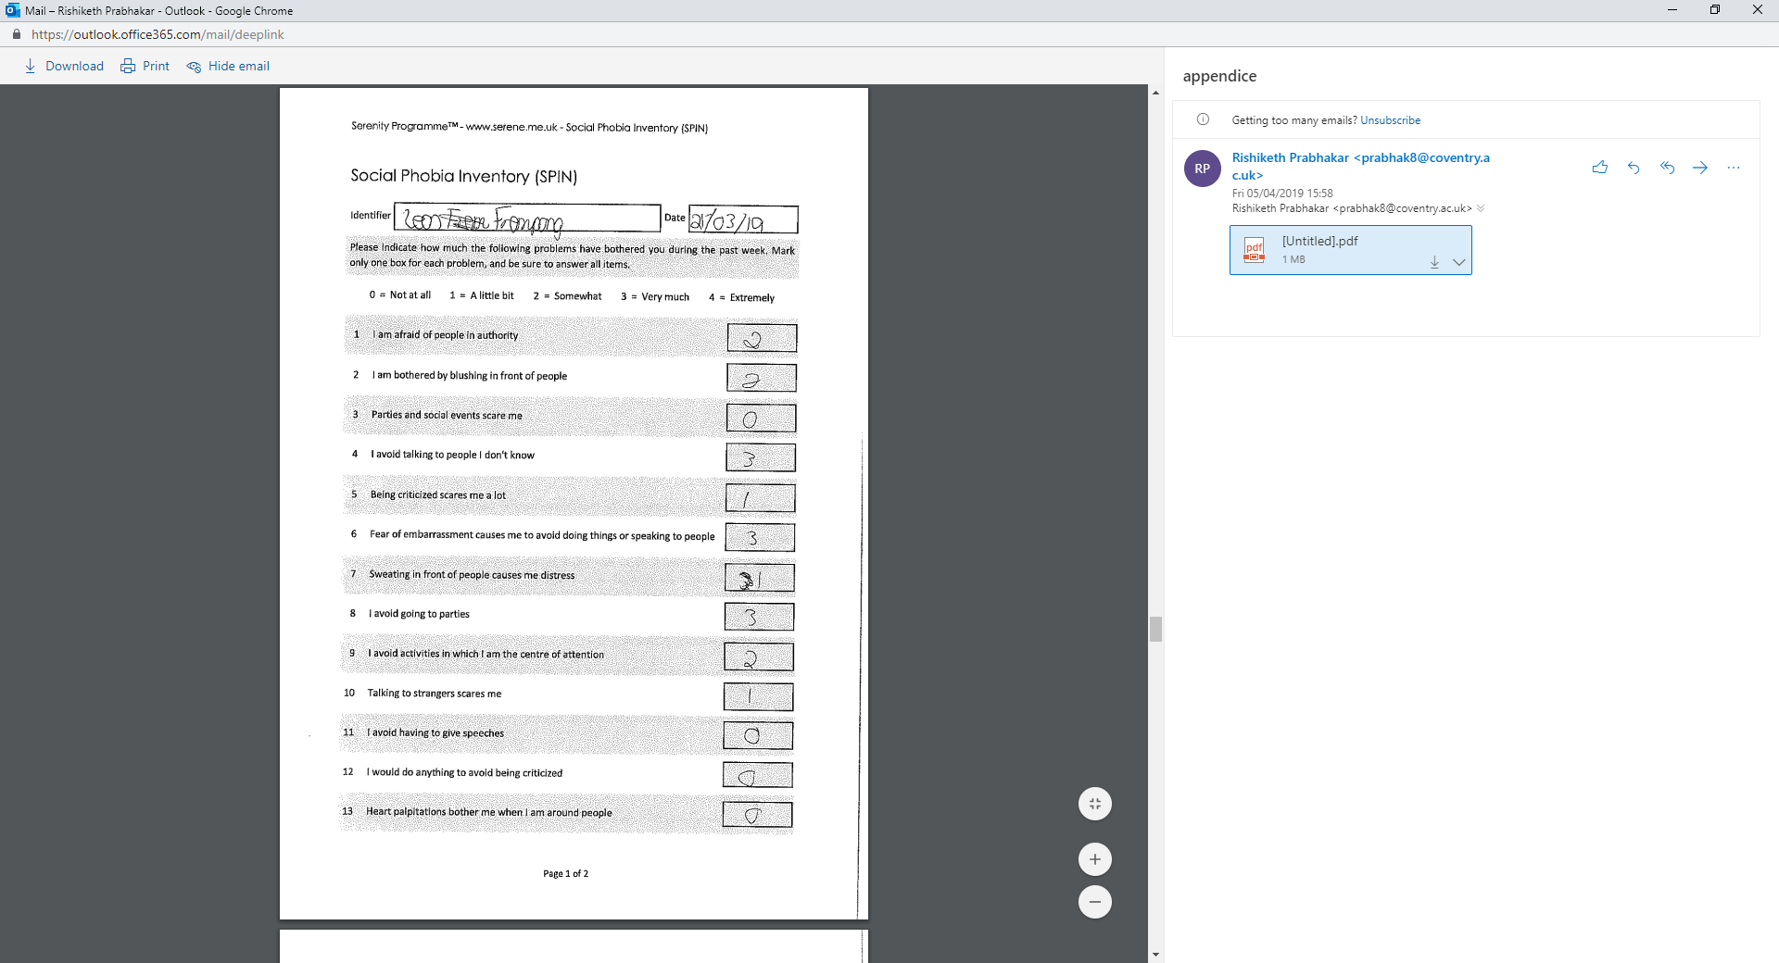

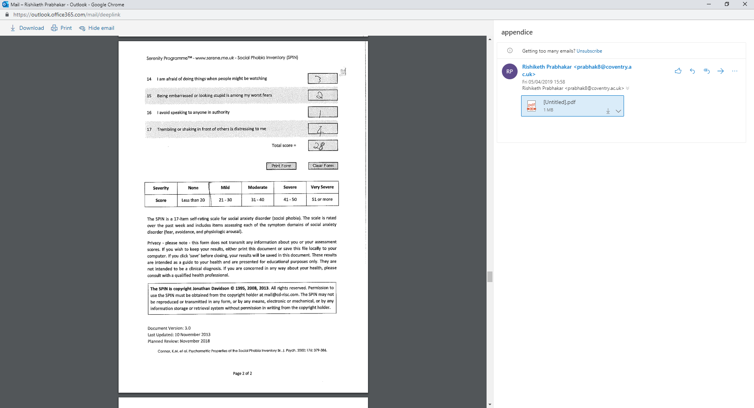

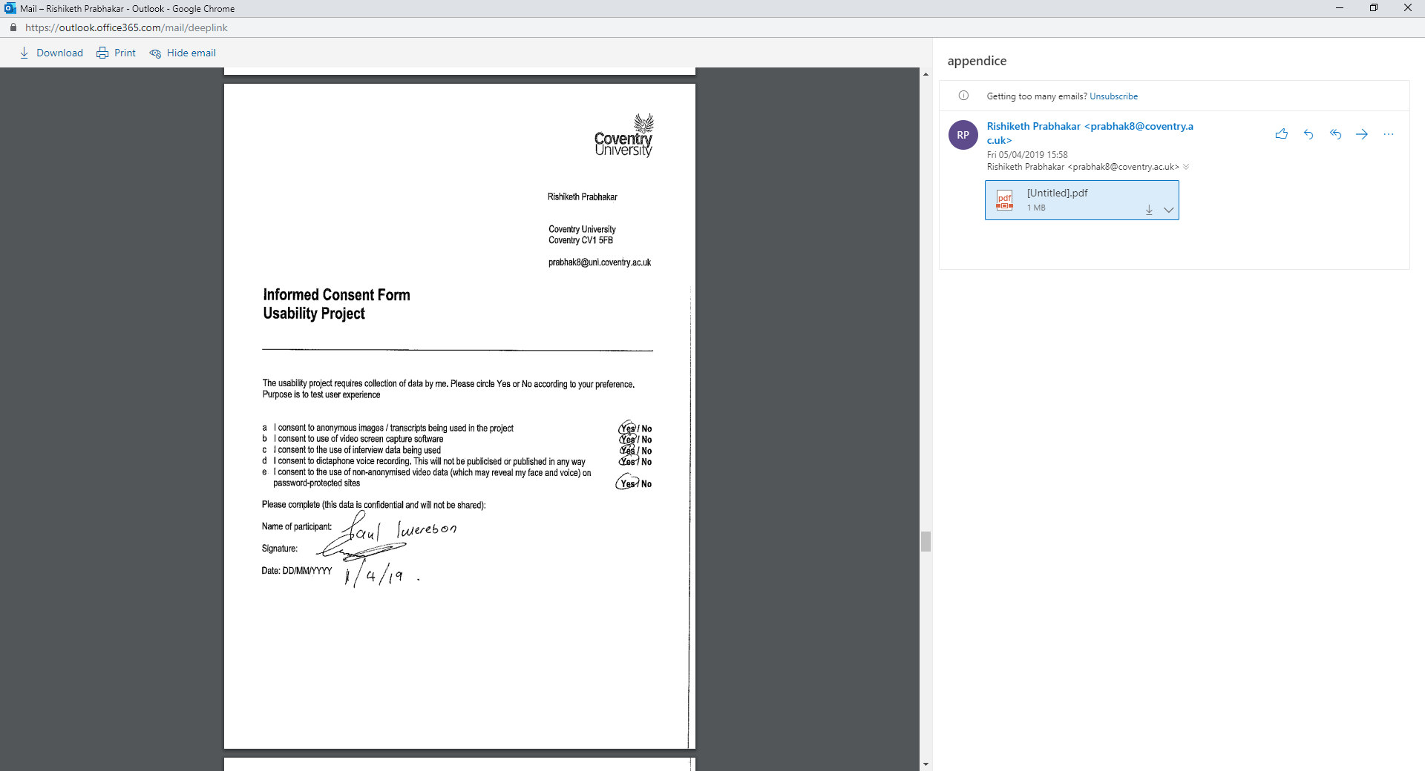

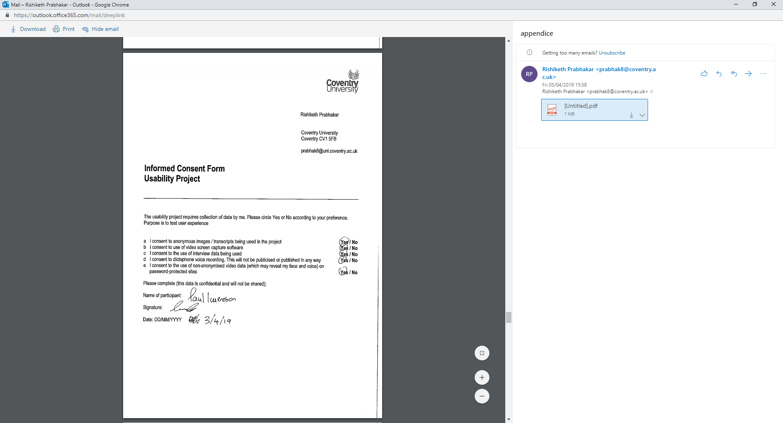

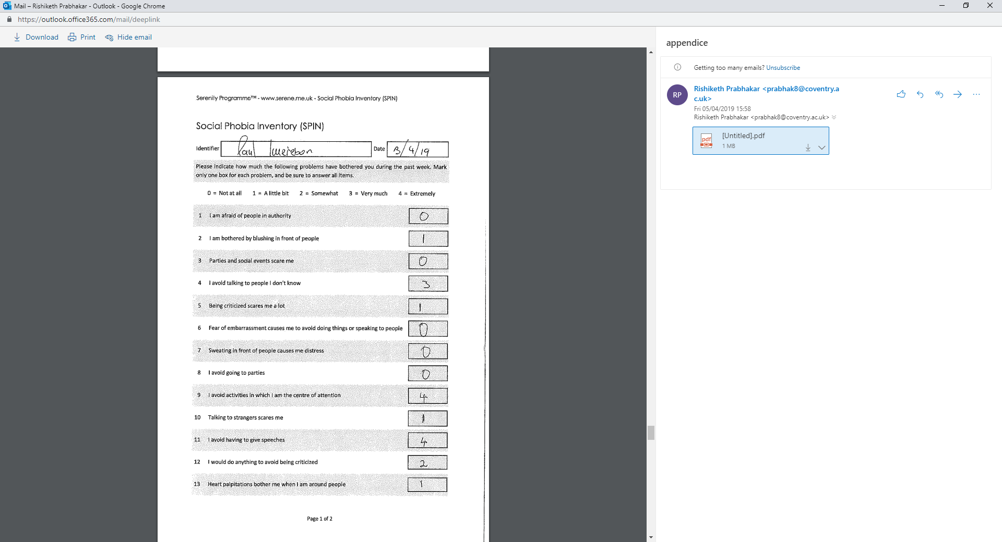

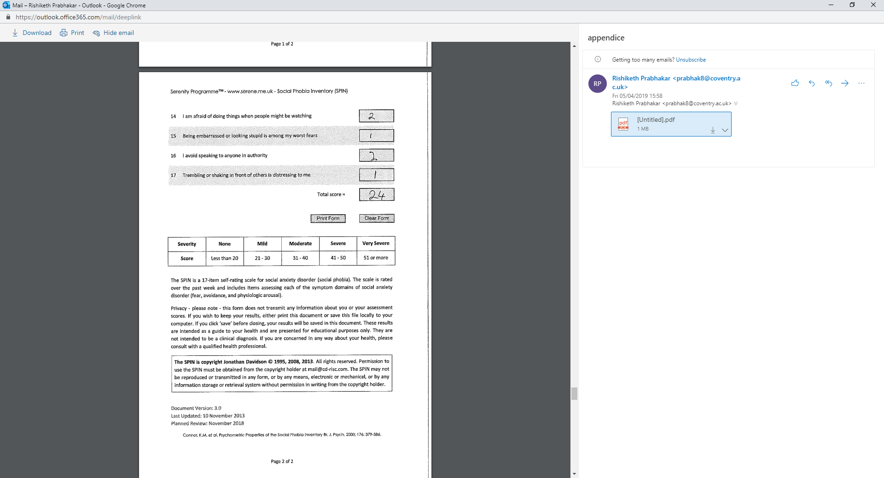

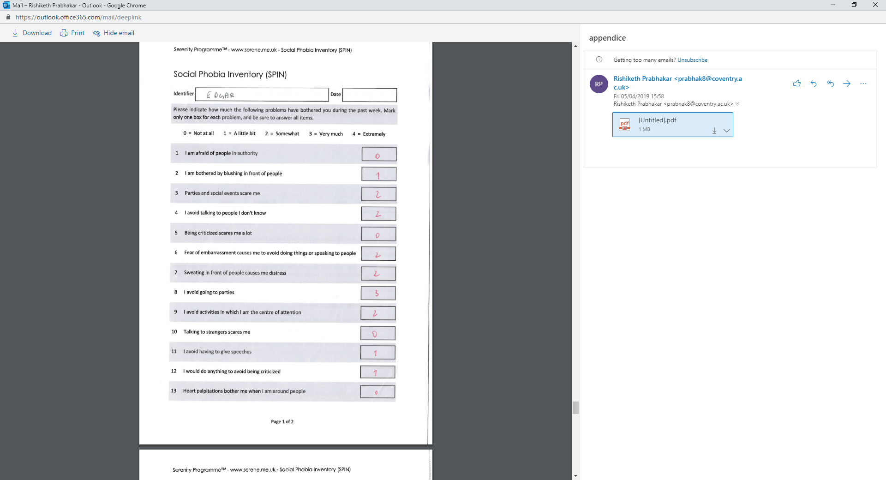

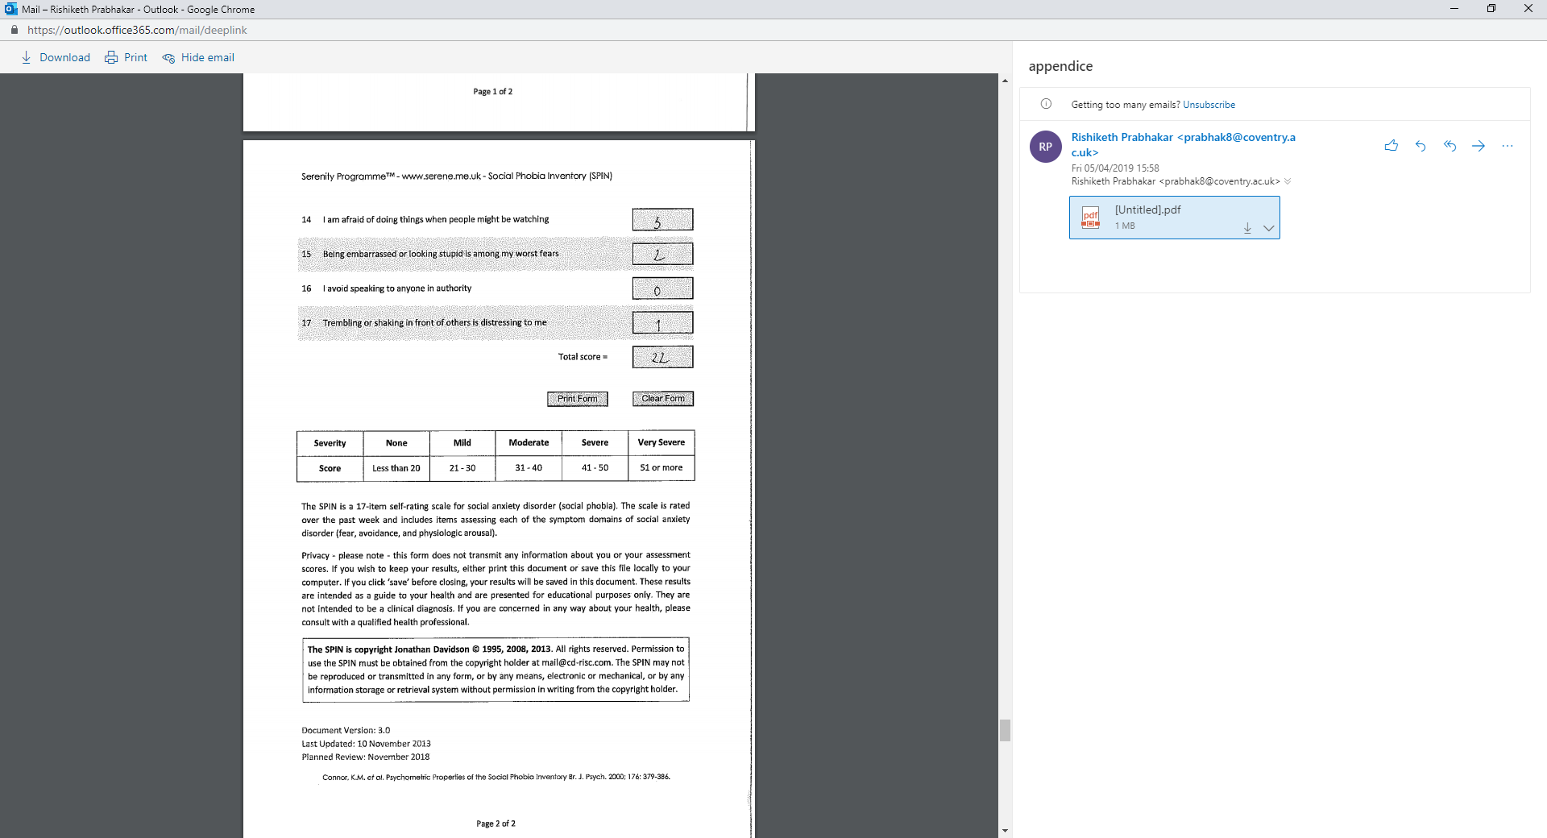

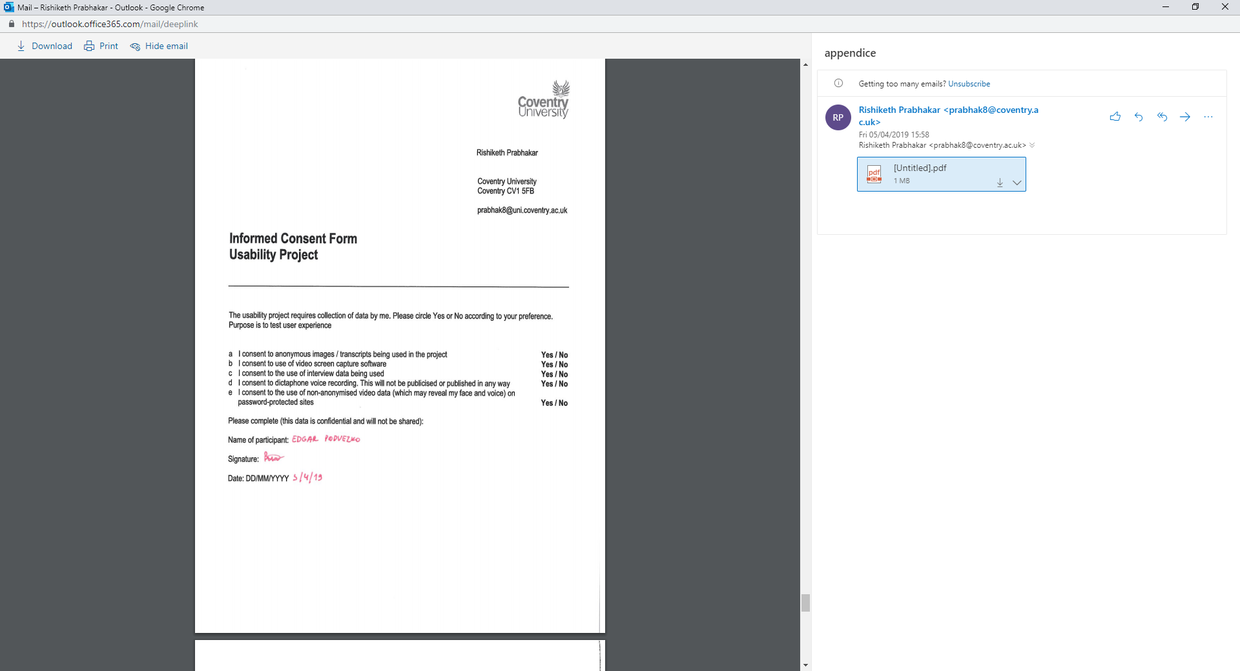

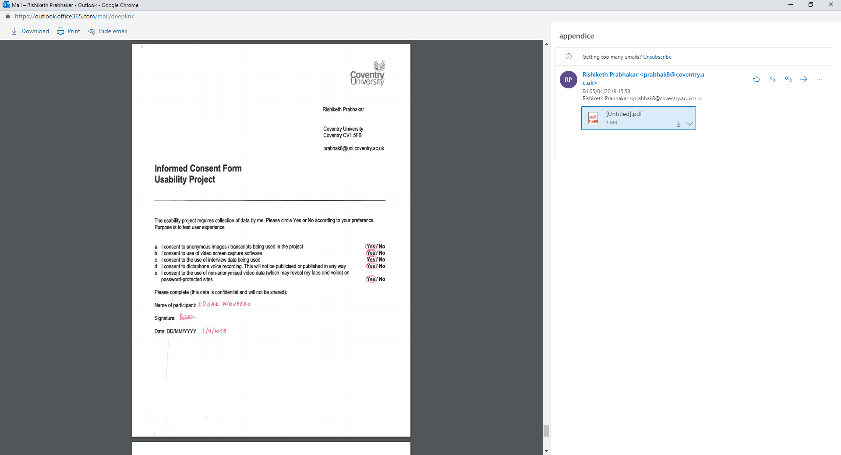

Thank You.